**The Sloan Digital Sky Survey (SDSS)**

(Space Server Dataset)

**Introduction**

The Sloan Digital Sky Survey (SDSS) is one of the largest; most detailed and most often cited astronomical surveys that have ever existed.

The goal is to expand understanding of the large-scale evolution and structure of the universe, the formation of stars and galaxies, the history of the Milky Way, and the science behind dark energy

The Sloan Digital Sky Survey is committed to working towards making the science and engineering results of surveys accessible to the public.

In cooperation with the Astrophysical Research Consortium, the Foundation has helped build and operate a pioneering, specially designed telescope and experiments to observe and achieve information on millions of stars, galaxies, quasars and other cosmological phenomena

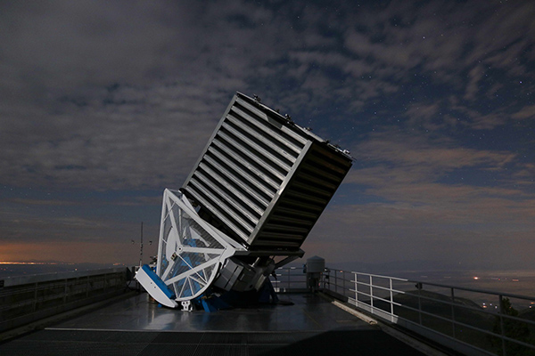

**The SDSS telescope at night**  
Image Credit: Patrick Gaulme

The survey’s mission is ambitious: It aims to create a detailed, three-dimensional map of the universe, with deep multi-color images of one third of the sky, and spectra for more than three million astronomical objectsusing a 2.5-meter, wide-angle optical telescope located at the Apache Point Observatory in New Mexico, United States.

Images were taken using a [photometric system](https://en.wikipedia.org/wiki/Photometric_system) of five filters (named *u*, *g*, *r*, *i* and *z*). These images are processed to produce lists of objects observed and various parameters, such as whether they seem point-like or extended (as a galaxy might) and how the brightness on the [CCDs](https://en.wikipedia.org/wiki/Charge-coupled_device) relates to various kinds of [astronomical magnitude](https://en.wikipedia.org/wiki/Apparent_magnitude).

Using these photometric data, stars, galaxies, and quasars are also selected for [spectroscopy](https://en.wikipedia.org/wiki/Spectroscopy).

**Problem definition:**

The aim is to study the Sloan Digital Sky Survey, which offers public data of space observations and predict different types of astronomical objects like stars, galaxies, and quasars using various classification algorithms.

The data consists of 10,000 observations of space taken by the SDSS. Every observation is described by 17 feature columns and 1 class column which identifies it to be a star, galaxy or quasar.

Dataset: <https://raw.githubusercontent.com/dsrscientist/dataset1/master/Skyserver.csv>

In order to make the article intuitive, we will learn all the concepts while simultaneously working on a Sloan digital sky survey data –

**Data Description:**

The table results from a query which joins two tables (actual views): "PhotoObj" which contains photometric data and "SpecObj" which contains spectral data.

1. objid = Object Identifier, each catalog object has a unique combination of run-camcol-fieldid-rerun;this combination is hashed into a single 64-bit integer called ObjID
2. ra = J2000 Right Ascension (r-band): Right ascension (abbreviated RA) is the angular distance measured eastward along the celestial equator from the Sun at the March equinox to the hour circle of the point above the earth in question.
3. dec = J2000 Declination (r-band): these astronomical coordinates specify the direction of a point on the celestial sphere (traditionally called in English the skies or the sky) in the equatorial coordinate system.

The Thuan-Gunn astronomic magnitude system u, g, r, i and z represents the response of the five bands of telescope

1. u = better of DeV/Exp magnitude fit
2. g = better of DeV/Exp magnitude fit
3. r = better of DeV/Exp magnitude fit
4. i = better of DeV/Exp magnitude fit
5. z = better of DeV/Exp magnitude fit

Run, rerun, camcol and field are features which describe a field within an image taken by the SDSS. A field is basically a part of the entire image corresponding to 2048 by 1489 pixels

1. run = Run Number, identifies the specific scan,
2. rerun = Rerun Number
3. camcol = Camera column, the camera column, a number from 1 to 6, identifying the scan line within the run
4. Field = Field number, the field number typically starts at 11 (after an initial ramp up time), and can be as large as 800 for particularly long runs.
5. specobjid = Object Identifier
6. redshift = Final Redshift
7. plate = plate number
8. mjd = MJD of observation
9. fiberid = fibre ID
10. class = object class (galaxy, star or quasar object)

**Understanding the class variables in detail:**

1. A **GALAXY** is a gravitationally bound system of stars, stellar remnants, interstellar gas, dust, and dark matter. Galaxies are categorised according to their visual morphology as elliptical, spiral, or irregular.
2. A **STAR** is a type of astronomical object consisting of a luminous spheroid of plasma held together by its own gravity. The nearest star to Earth is the Sun.
3. A **QUASAR**, also known as quasi-stellar object, is an extremely luminous active galactic nucleus (AGN). The power radiated by quasars is enormous.

**Exploratory Data Analysis:**



Why analyse data?

It is a good practice to understand the data first and try to gather as many insights from it. Data in itself is merely facts and figures.

EDA is all about making sense of data in hand, before getting them dirty with it. It involves organizing, interpreting, structuring and presenting the data into useful information that provides context for the data.

Data Analysis helps to:

* Explore the meaning behind numbers and figures
* Analyse the cause of certain events based on data findings
* Present technical insights.

Python is a great language for doing data analysis, primarily because of the fantastic ecosystem of data-centric Python packages. Pandas are one of those packages and makes importing and analyzing data much easier.

To start with let us import all necessary libraries and packages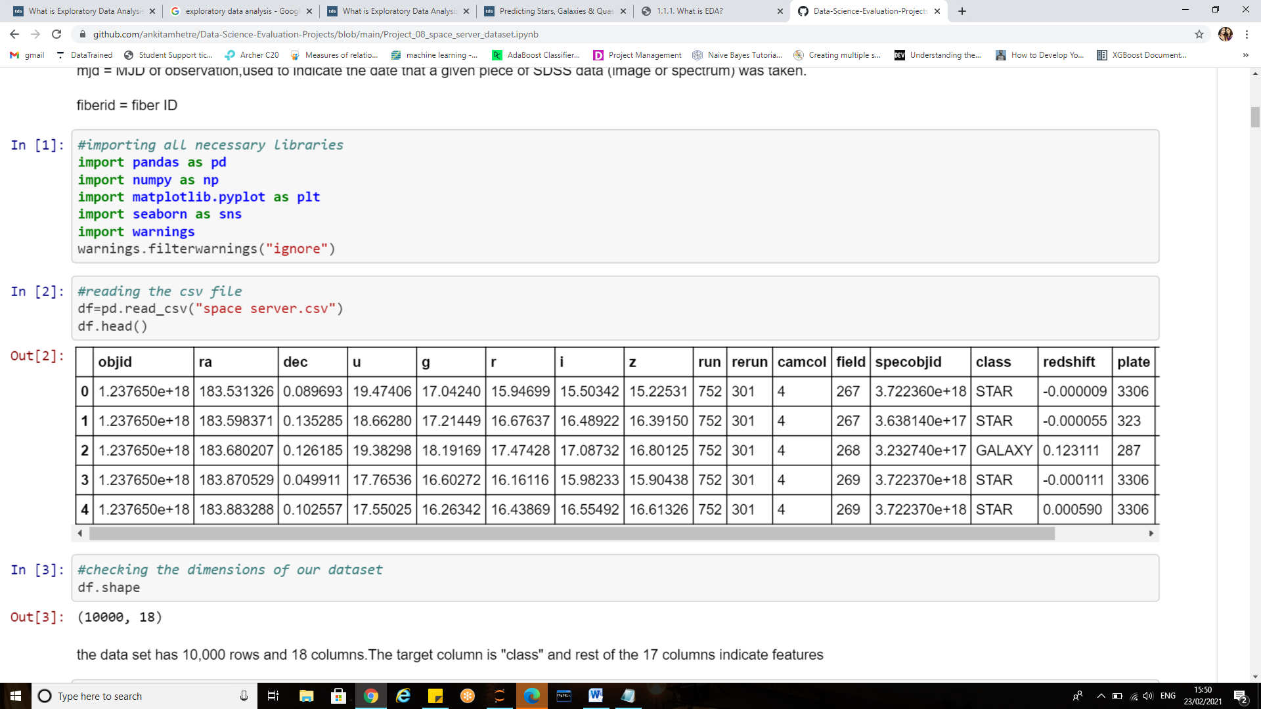the dataset is present as a csv (comma separated value) file and is loaded using pd.read_csv function.

df.head (): This function returns the first n rows for the object based on position. It is useful for quickly testing if your object has the right type of data in it.

Similarly “.tail ()” returns last five observations of the data set.

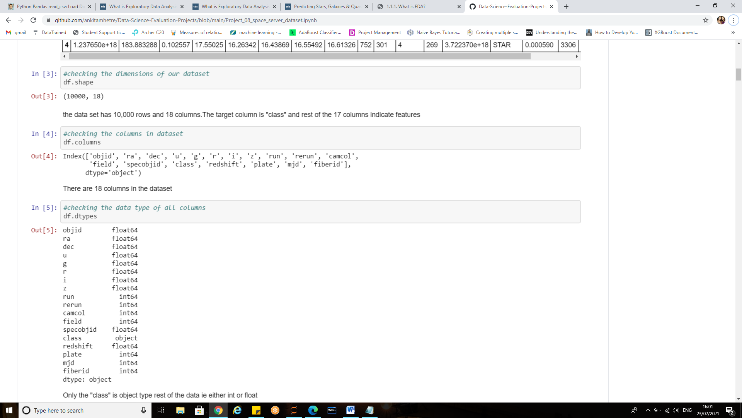

**Df.shape**: returns a tuple representing the dimensionality of the data frame.

The SDSS dataset has 1000 rows and 18 columns

**Df.columns** attribute returns the column labels of the Dataframe.

There are 17 features (independent variables) and 1 target variable i.e.’class’

**df.dtypes** attribute return the dtypes in the DataFrame. It returns a Series with the data type of each column.

It can be seen that only ‘class’ column i.e. label/target is object type rest of the columns are either int or float type.

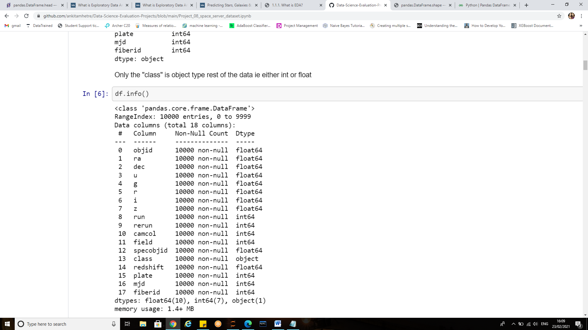

**df.info()** method prints information about a DataFrame including the index dtype and columns, non-null values and memory usage.

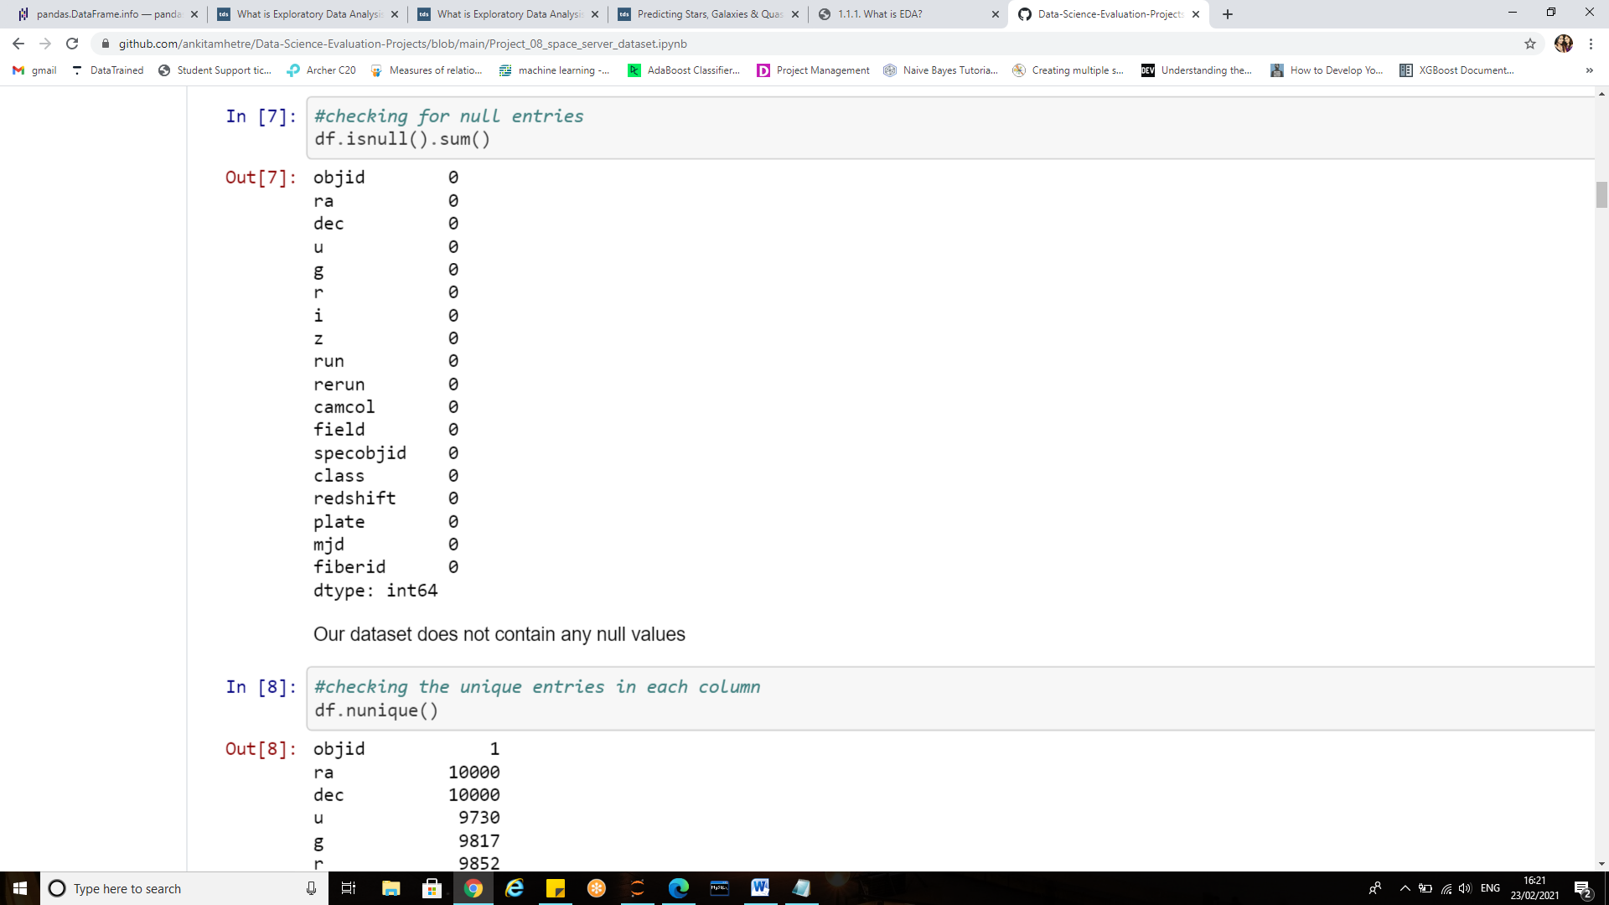

**isnull(). sum()** returns the number of missing values in the data set. The data has no NaN values and is clean.

**Visualizations:**

As a data scientist, we always question the amount of time we put into data visualization. Don’t we?



.

Ideally we should put more emphasis and efforts into ensuring a thorough analysis rather than just making the graphs pretty and investing lot of time in just decorating them .Prettier graphs won’t necessarily mean great analysis.

Data analysis and data visualization are not entirely exclusive work sets – they co-exist and feed off of each other. Data science is more than just building machine learning models; it is also about explaining the models and using them to drive data-driven decisions.

In the journey from analysis to data-driven outcomes, data visualization plays a very important role of presenting data in a powerful and credible way.

***Thus Data visualization is an art that data scientists need to be good at in order to tell a compelling story from their analysis***

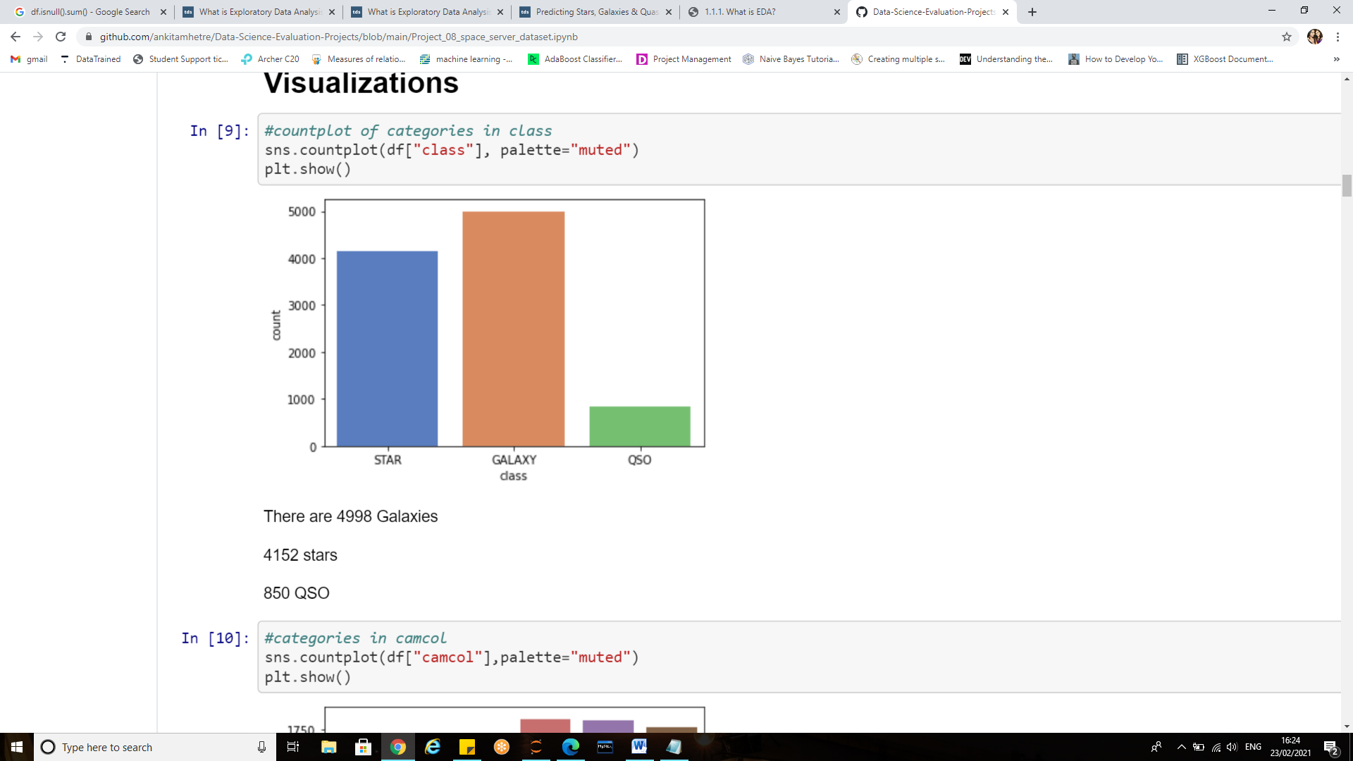 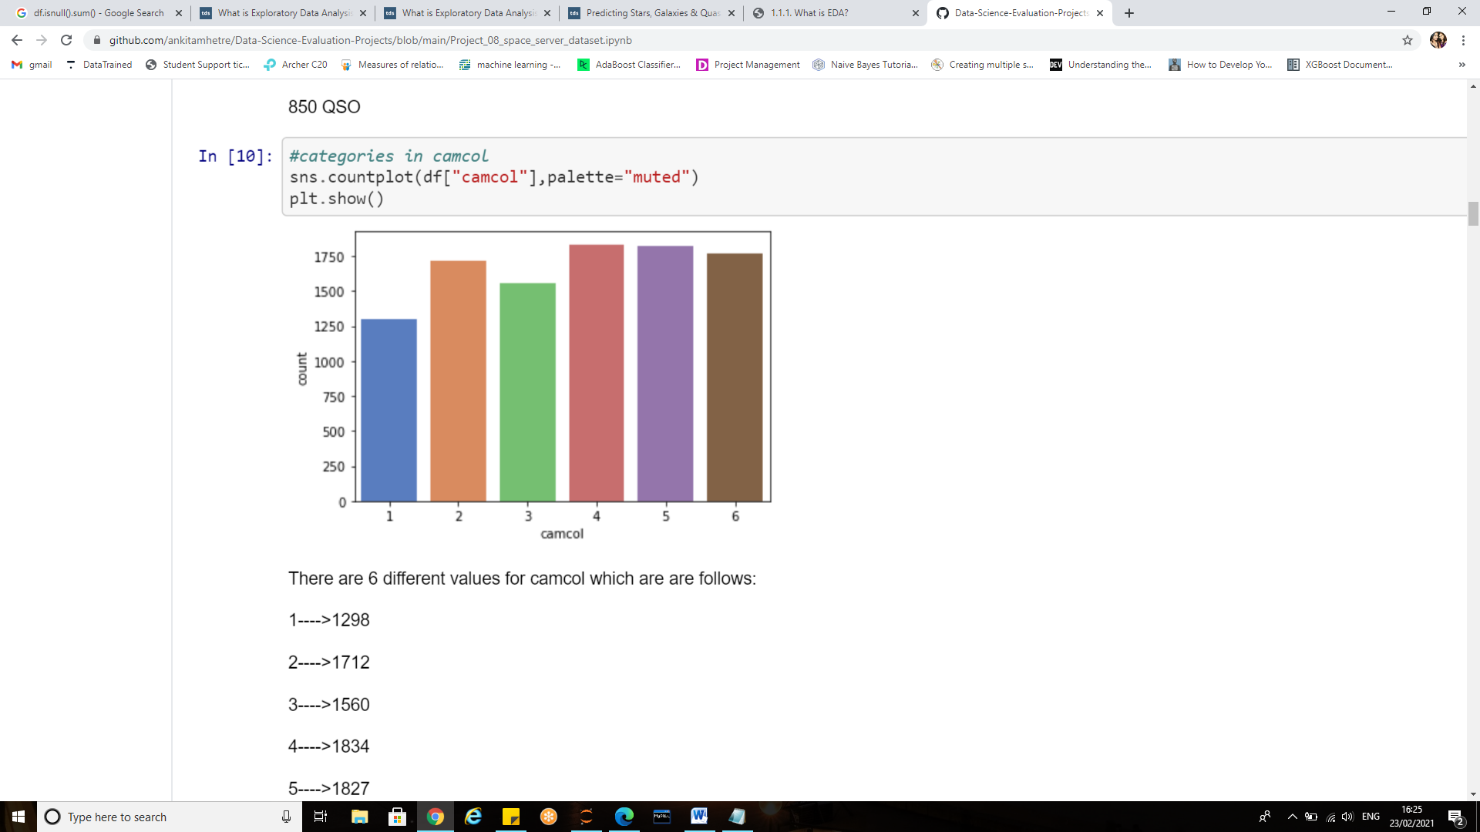

**Sns.countplot ():** Shows the counts of observations in each categorical bin using bars.

Among all the 1000 records there were

* 4998 Galaxies
* 4152 stars
* 850 QSO

There are 6 different values for camcol which are as follows:

* Camcol 1---->1298
* Camcol 2---->1712
* Camcol 3---->1560
* Camcol 4---->1834
* Camcol 5---->1827
* Camcol 6----->1769

**Category plot**

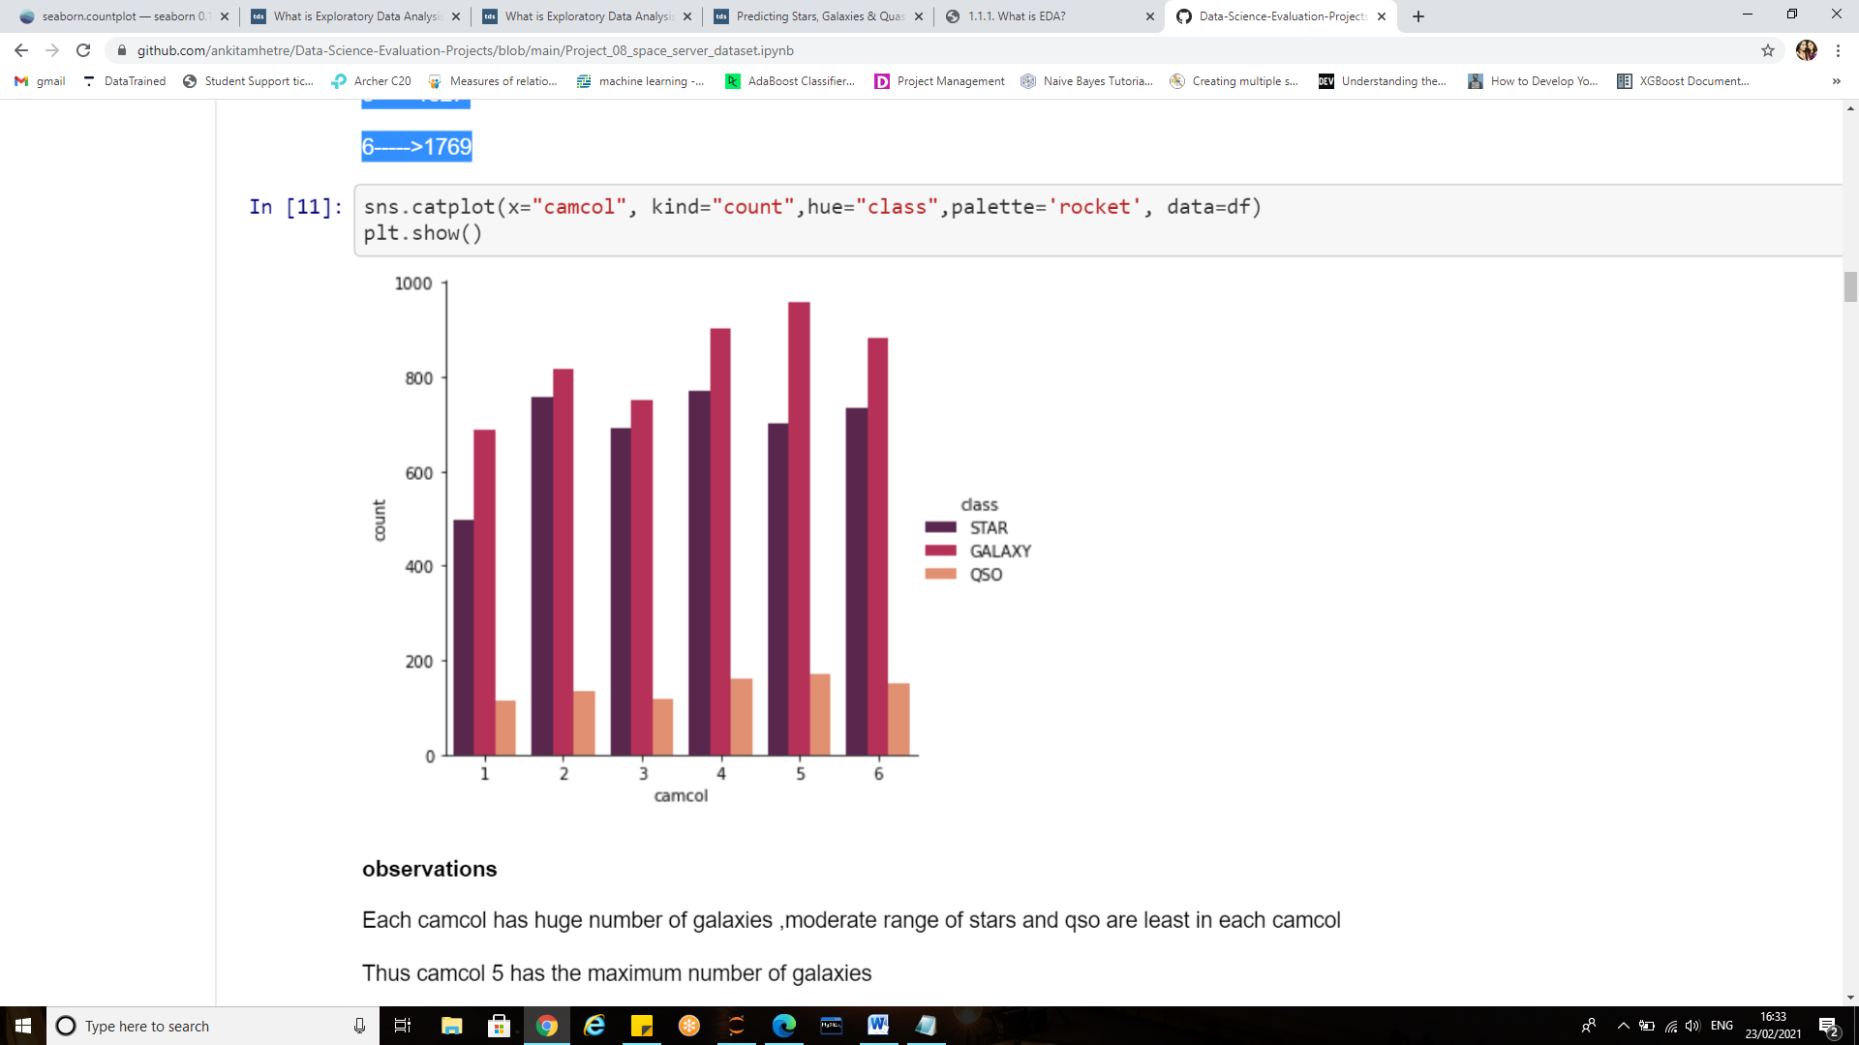

The **sns.catplot ()** is used to plot the categorical variables.Catplot function can do all types of plots and one can specify the type of plot one needs with the kind parameter. By default cat plot creates strip plot with default jitter showing the original data points.

From the plot it can be observed that:

Each camcol has huge number of galaxies , moderate range of stars and qso are least in each camcol

* Thus camcol 5 has the maximum number of galaxies
* QSo are highest in camcol 5
* camcol 2 has highest number of stars

**Histogram:**

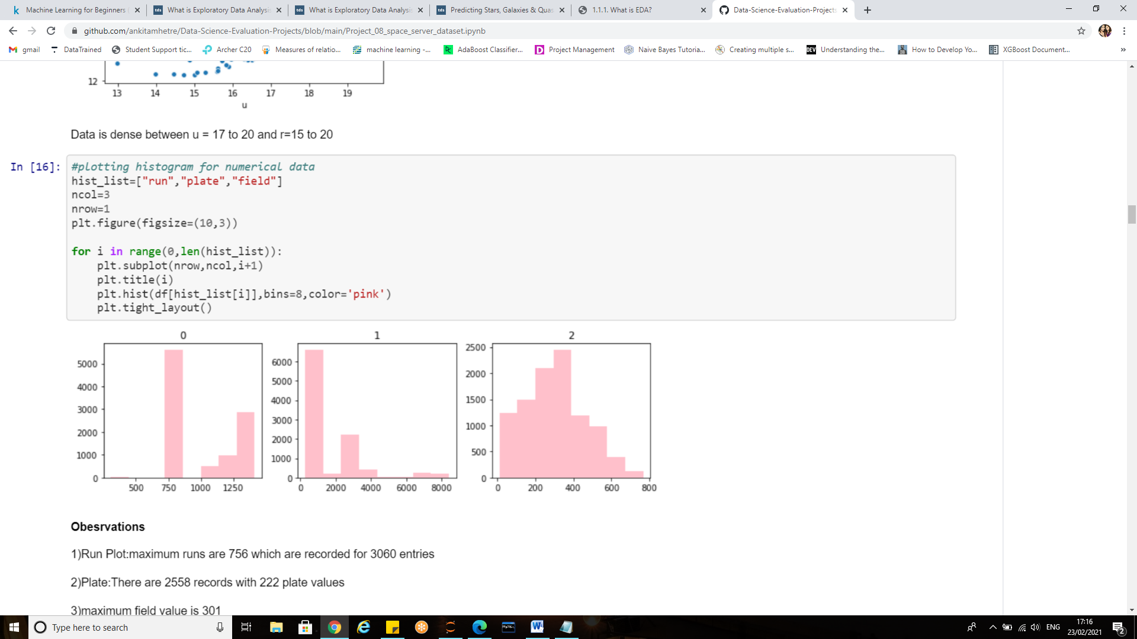

A [histogram](https://en.wikipedia.org/wiki/Histogram) is a representation of the distribution of data. For the numerical columns in our dataset hist plot is made. Subplot will result in multiple plots in a single row

* Run Plot: maximum runs are 756 which are recorded for 3060 entries
* Plate: There are 2558 records with 222 plate values
* maximum field value is 301

**Bivariate Analysis using scatter plot:**

Scatter plot can be used to depict the relationship between x and  y .

Scatter plot is a diagram where each value in the data set is represented by a dot. The position of each dot on the horizontal and vertical axis indicates values for an individual data point.

Scatter plots are used to observe relationships between variables.

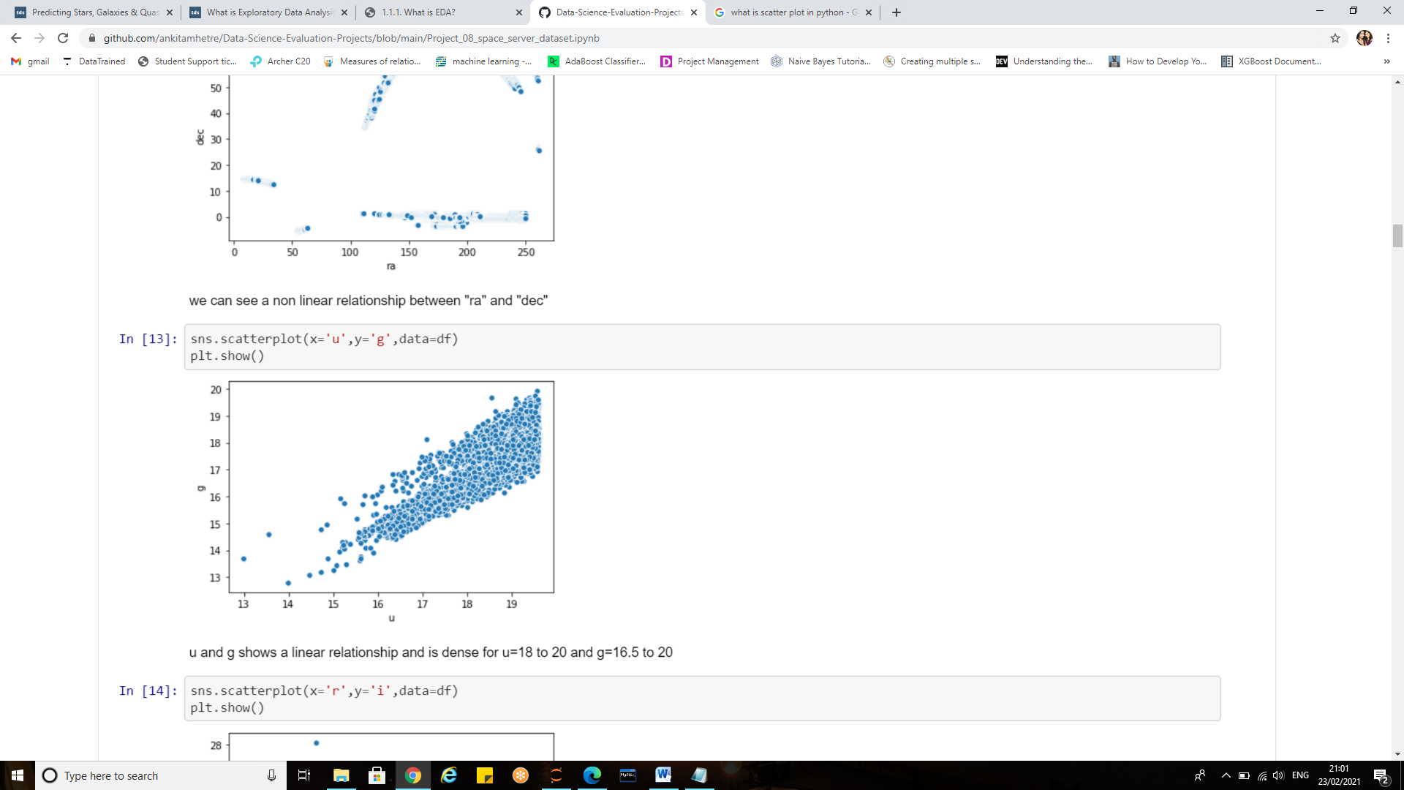 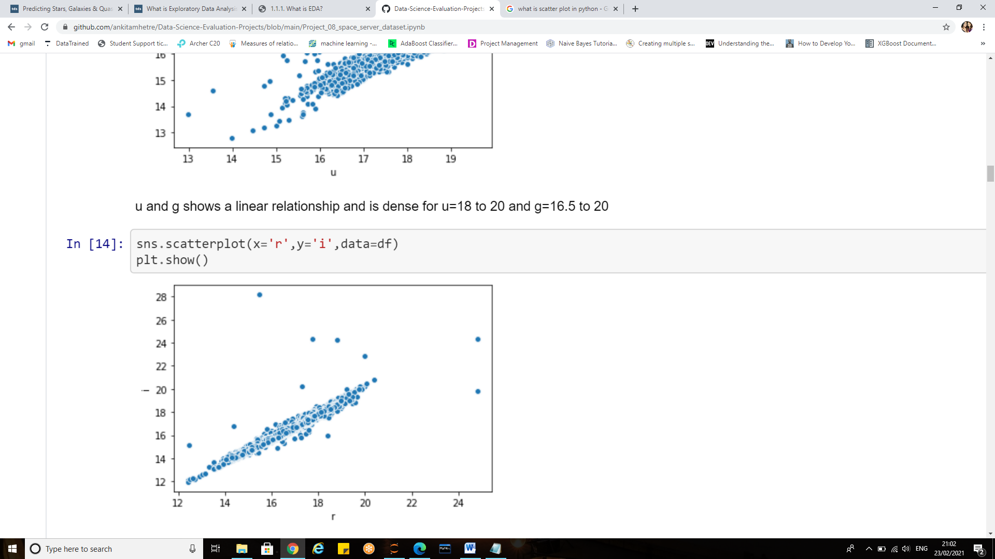

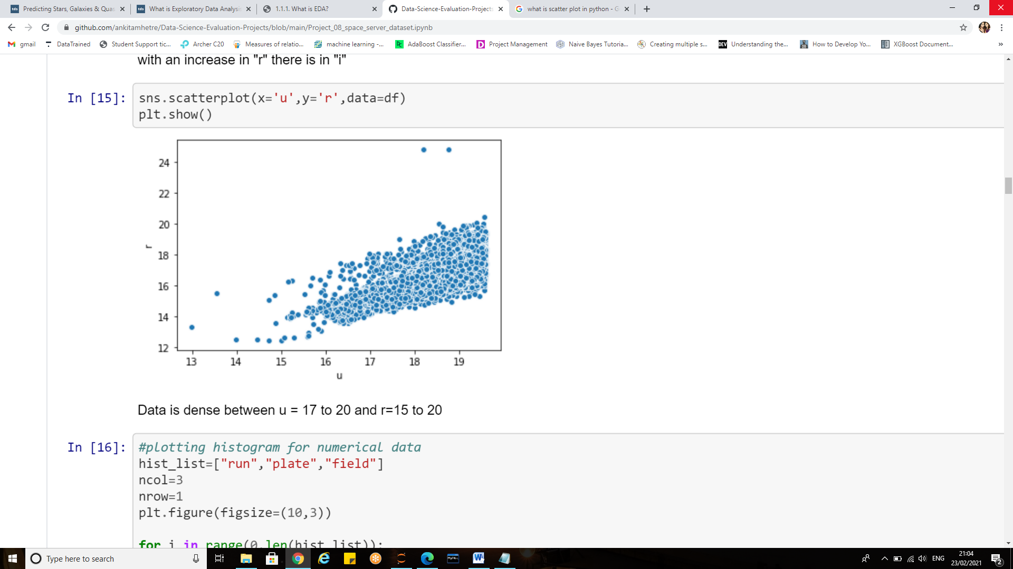 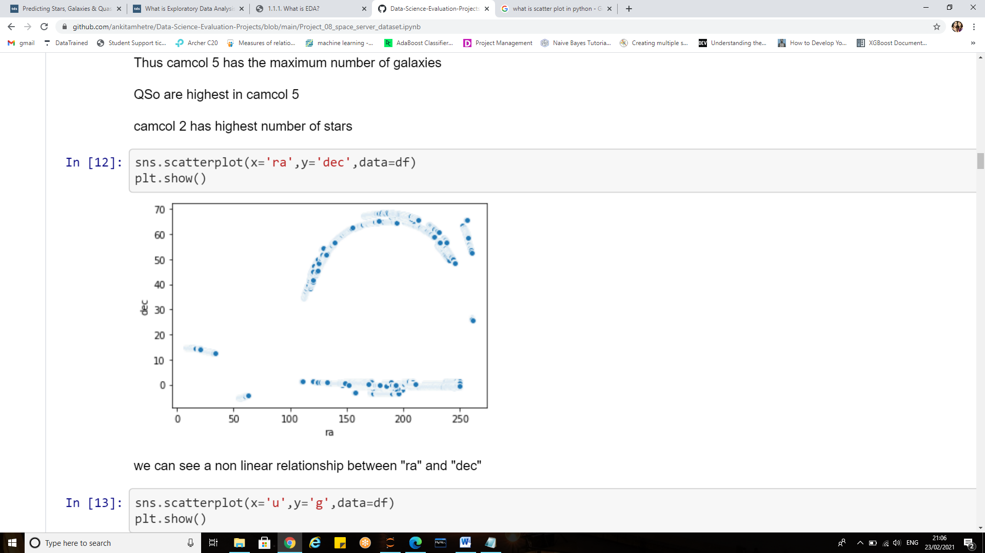

**Observations:**

Fig1) u and g shows a linear relationship and is dense for u=18 to 20 and g=16.5 to 20

Fig 2) for the relationship between ‘r’ and ‘i’ with an increase in "r" there is in "i" i.e they show linear relationship

Fig 3) the variables show linear relationship data is dense between u = 17 to 20 and r=15 to 20

Fig 4) we can see a non-linear relationship between "ra" and "Dec"

**Distribution plot**

The distplot() function combines the matplotlib hist function with the seaborn kdeplot() and rugplot() functions.

 To check the linearity of the variables it is a good practice to plot distribution graph and look for skewness of features..

**Properties of a normal distribution**

* The mean, mode and median are all equal.
* The curve is symmetric at the center (i.e. around the mean, μ).
* Exactly half of the values are to the left of center and exactly half the values are to the right.
* The total area under the curve is 1.

[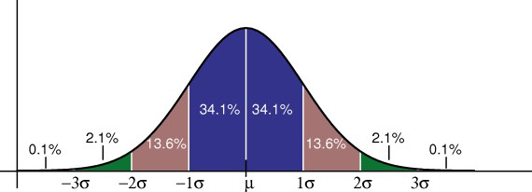](https://www.statisticshowto.com/wp-content/uploads/2013/02/standard-normal-distribution.jpg)

The empirical rule tells you what percentage of your data falls within a certain number of standard deviations from the mean:  
• 68% of the data falls within one standard deviation of the mean.  
• 95% of the data falls within two standard deviations of the mean.  
• 99.7% of the data falls within three standard deviations of the mean.

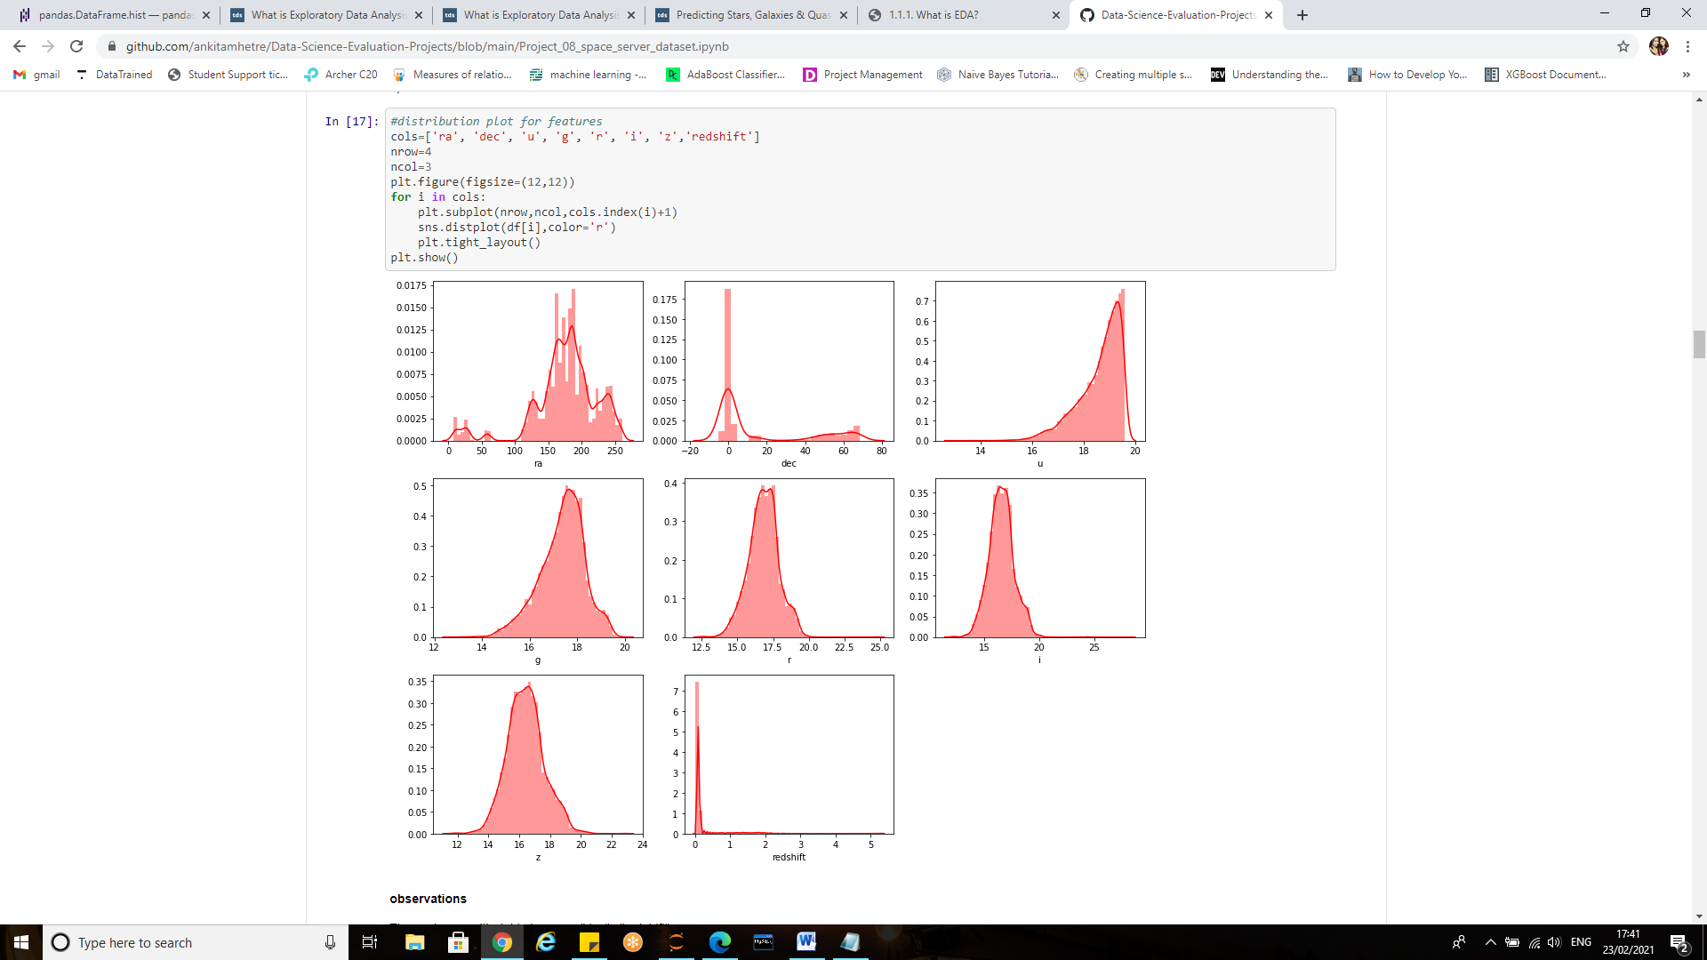

What is skewness?

Before getting into skewness let us see the normal distribution curve or Guassian Curve/distribution.

**Skewness** is a measure of the asymmetry of the probability distribution of a real-valued random variable about its mean. The skewness can be checked using df.skew ()

When a distribution is asymmetrical the tail of the distribution is skewed to one side-to the right or to the left. When the value of the skewness is negative, the tail of the distribution is longer towards the left hand side of the curve.

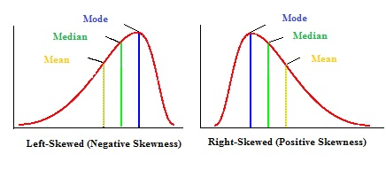

**Right skew**: the tail is on the right side, median is greater than the mode

Mean > Median > Mode

**Left skew:** the tail is on the left side, median is smaller than the mode. Mean < Median < Mode

In statistics, for a moderately skewed distribution, there exists a relation between mean, median and mode. This mean, median and mode relationship is known as the **“empirical relationship”**

**Observations:**

* "dec" and "redshift" columns show right skew
* "ra" ,"u" ,"g", "r", have left skew
* "i" and "z" have normal distributions.

**Box plot:**

A Box Plot is also known as **Whisker plot** is created to display the summary of the set of data values having properties like minimum, first quartile(25th percentile), median(50th percentile), third quartile(75th percentile) and maximum.

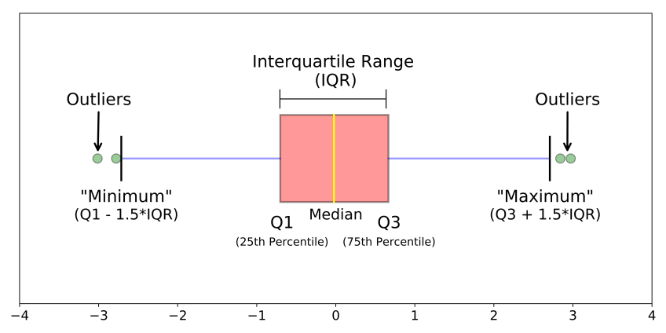

Box plot tells us about outliers and what their values are. It can also tell if data is symmetrical, how tightly the data is grouped, and if and how data is skewed.

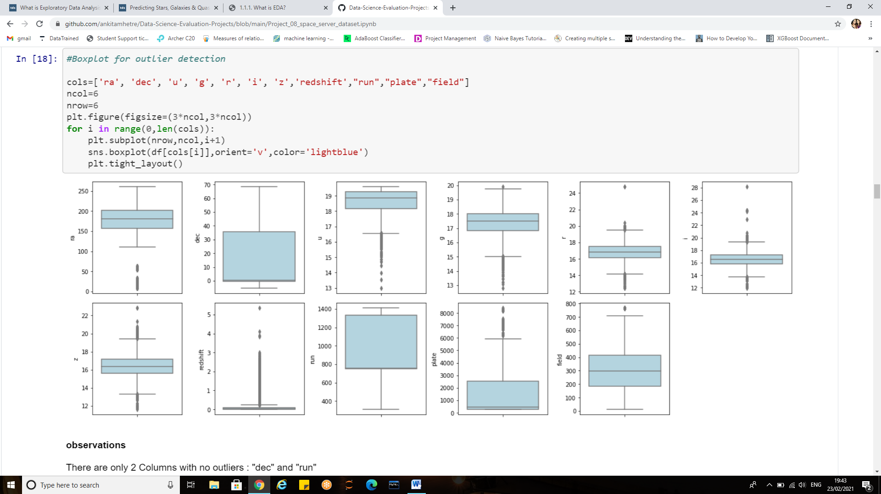

**Observations:**

* In the SDSS There are only 2 Columns with no outliers : "dec" and "run"
* "Redshift" has the maximum outliers.
* ‘Field’ have an outlier at approximately 800.
* The data for ‘r’ and ‘z’ is not tightly grouped.

**Statistical Analysis:**

One can find correlations using pandas “.corr()” function and can visualize the correlation matrix using a heatmap in seaborn.

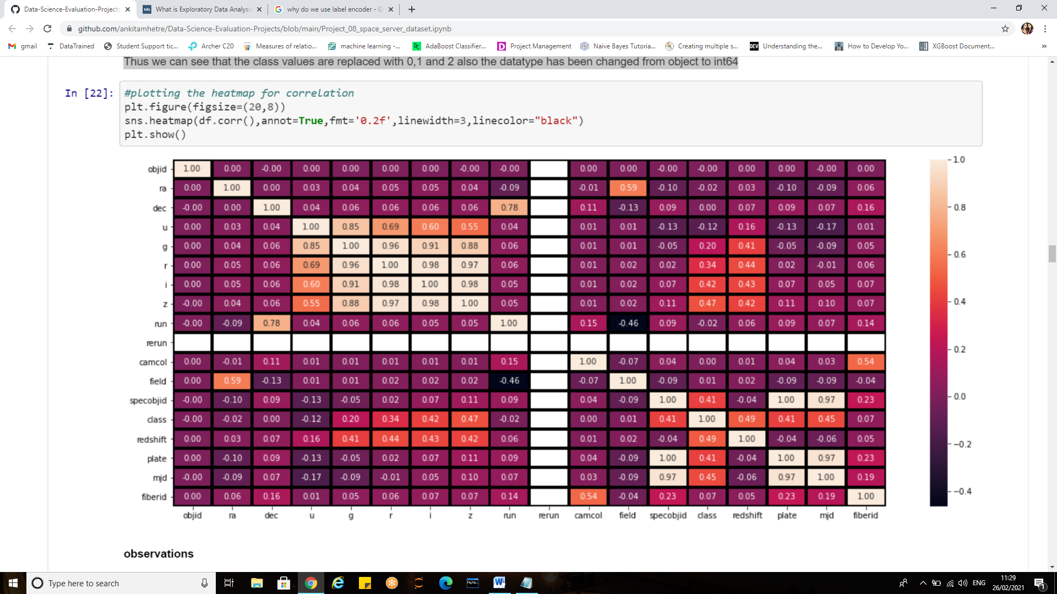

Dark shades represent positive correlation while lighter shades represent negative correlation.

Setting **annot=True**, we’ll get values by which features are correlated to each other in grid-cells.

**Fmt** is the String formatting code to use when adding annotations.

**Linewidth** is the width of the lines that will divide each cell.

**linecolor**, Color of the lines that will divide each cell.

**Observations**

Columns with **strong positive correlation** with target:

* "redshift"= (0.49)
* “z"= (0.47)
* "mjd"=0.45
* "i"=0.42

"Plate" has correlation of 0.41

Columns with **least correlation** with target are :

* ra
* run

Columns with **zero correlation** with target:

* objid
* dec
* camcol

Since correlation is zero we can infer there is no linear relationship between these three predictors and the target.

The correlation can also be visualized using bar graph as below:

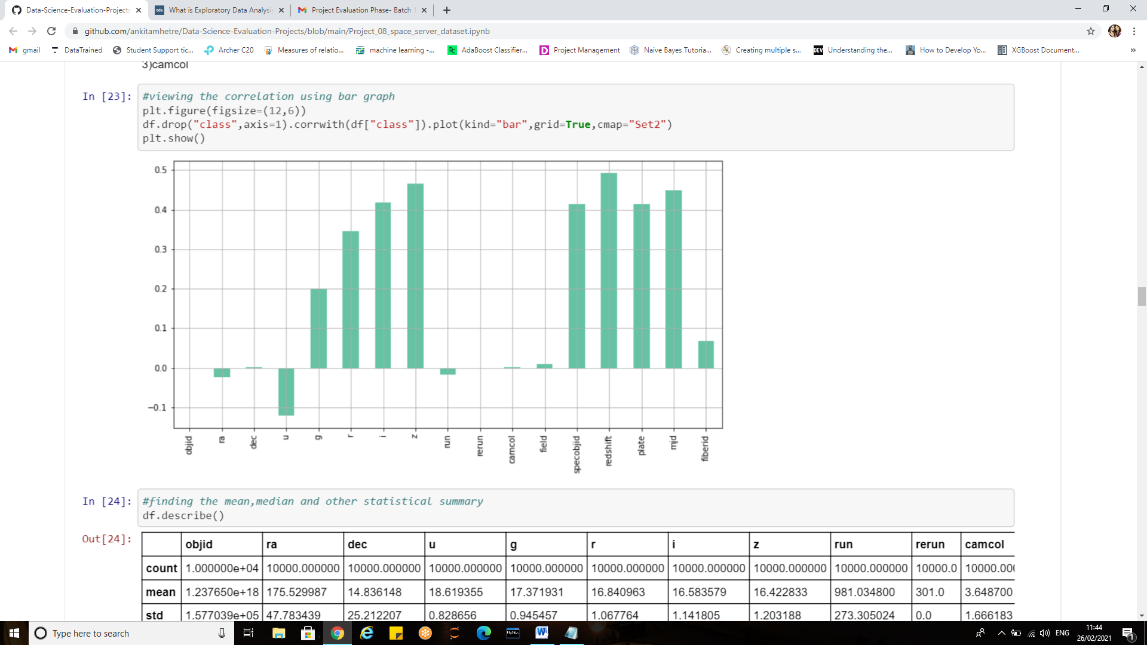

**Pandas.describe():**

Pandas describe() is used to view some basic statistical details like percentile, mean, standard deviation etc. of a data frame or a series of numeric values.

As shown in the output image, Statistical description of DataFrame is returned with the respective percentiles.

If there are the columns with strings, NaN will be returned for numeric operations. As the dataset here contains no string values NaN’s are not present.

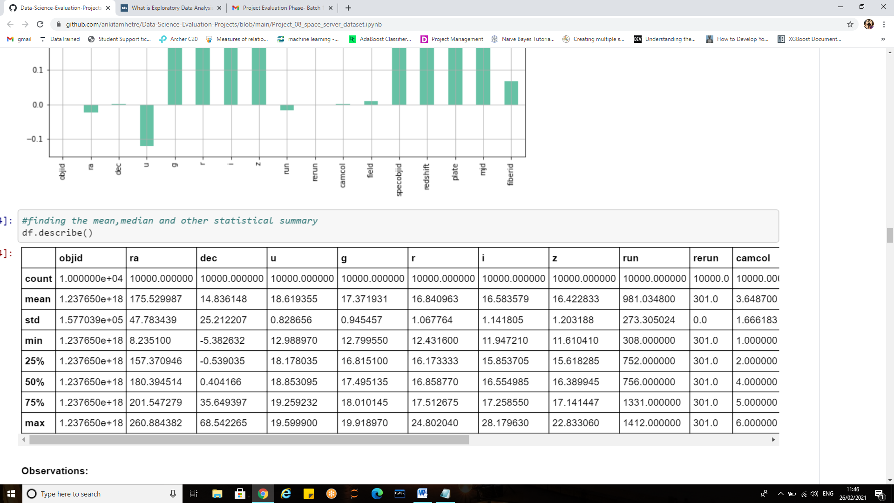

**df.describe(include='all')** can be used to describe all columns of a DataFrame regardless of data type.

#### Observations:

There are few columns with high standard deviation and they are as follows:

* ra ,
* dec,
* run ,
* field,
* plate ,
* mjd
* fiberid

Here as we can notice mean value is almost similar to the median value of each column which is represented by 50% (50th percentile) in index column.

There is notably a large difference between 75th percentile and max values of predictors ‘field’, ‘redshift’, ’plate’, ’specobjid’ and ‘fibreid’.

Thus for the observations where there is a difference between minimum value and 25th percentile, and 75th percentile and maximum value suggests that there are outliers present in our data set.

A heatmap can also be visualized for the describe method as shown below:

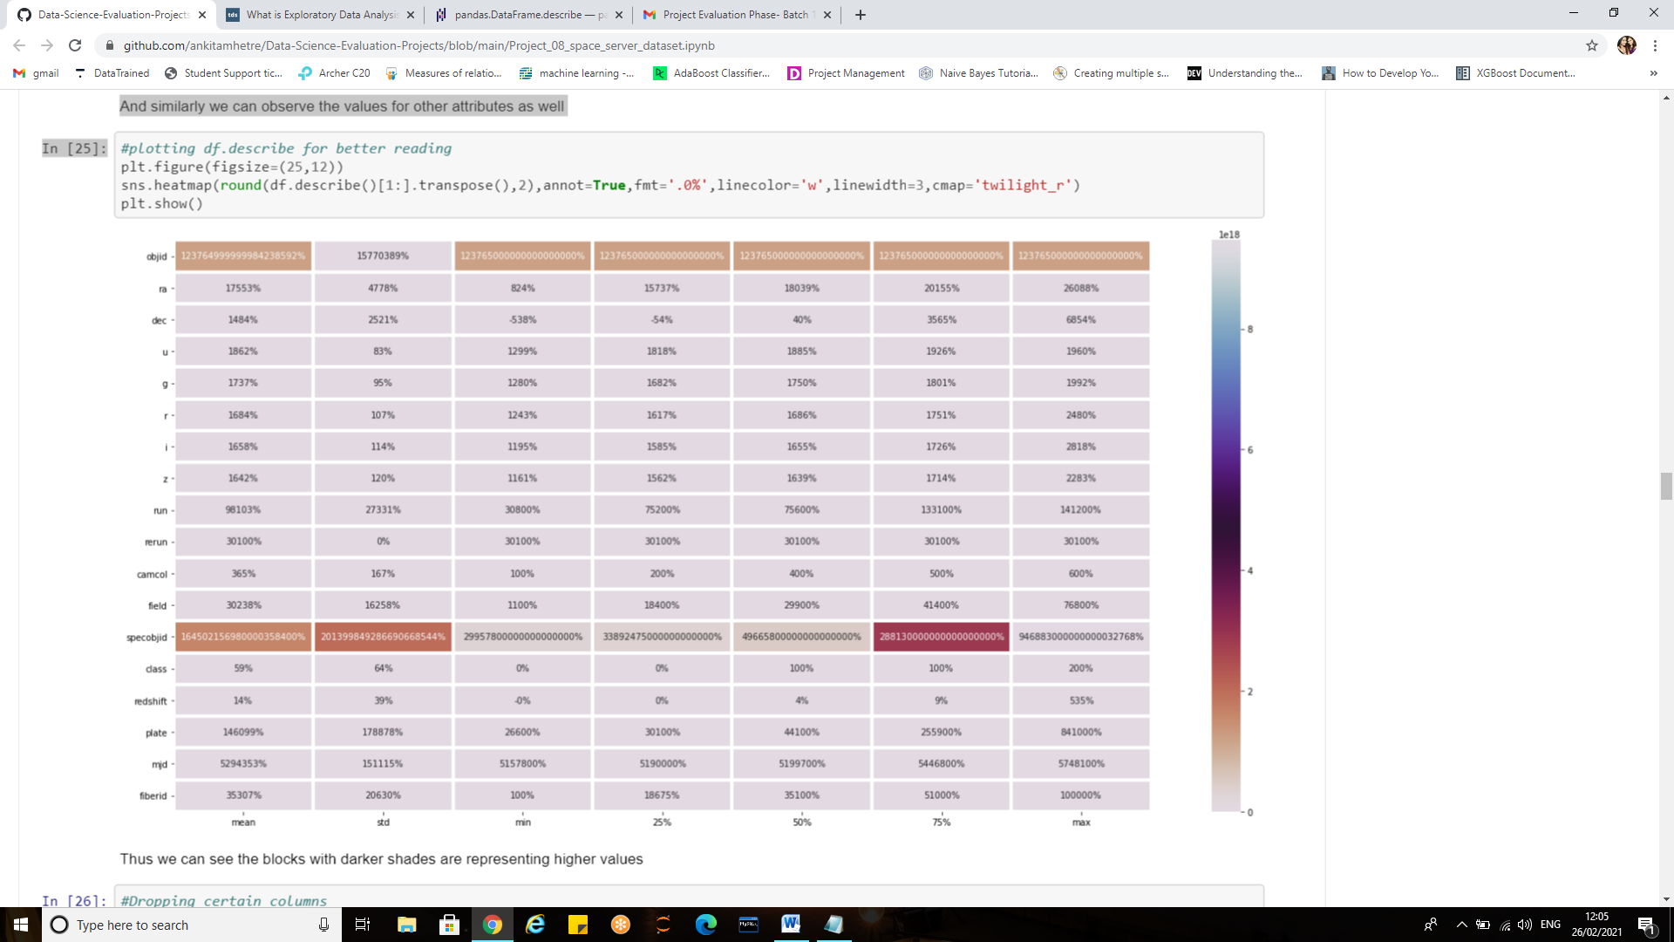

**Cmap**: it is the colormap, used for mapping data values to color space.

**.transpose ():** Reflect the Data Frame over its main diagonal by writing rows as columns and vice-versa. E.g. If we have an array of shape (X, Y) then the transpose of the array will have the shape (Y, X).

**Z-scores for Outlier Detection**:

A critical part of the EDA is the detection and treatment of outliers. **Outliers**are observations that deviate strongly from the other data points in a random sample of a population. Z-scores are a way to compare results to a “normal” population

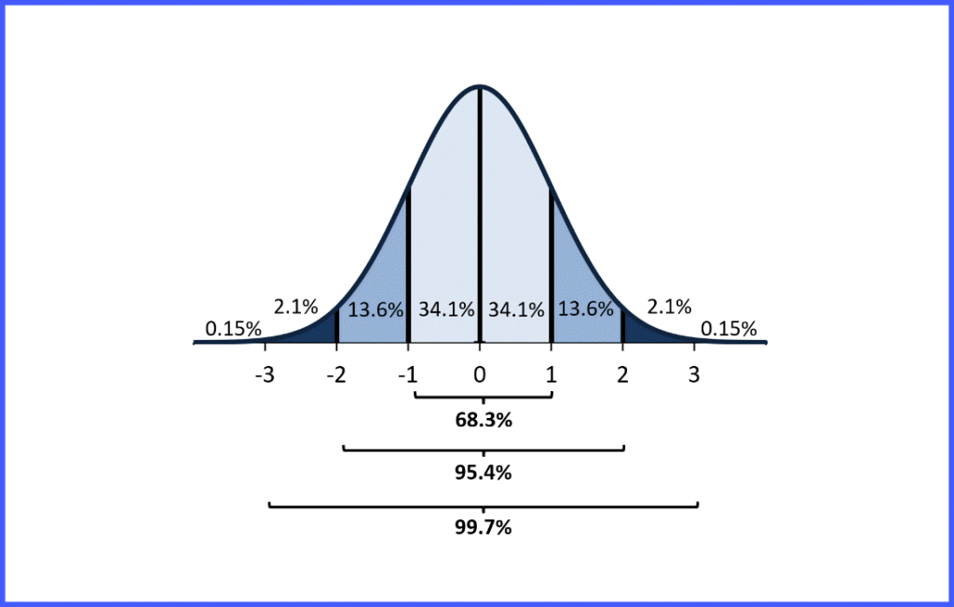

Emperial Rule and Z-score Probability 1

The z score tells you how many standard deviations from the mean your score is.

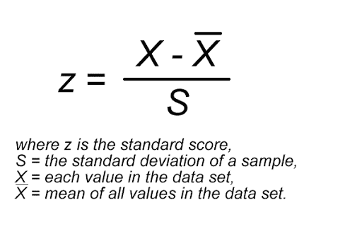

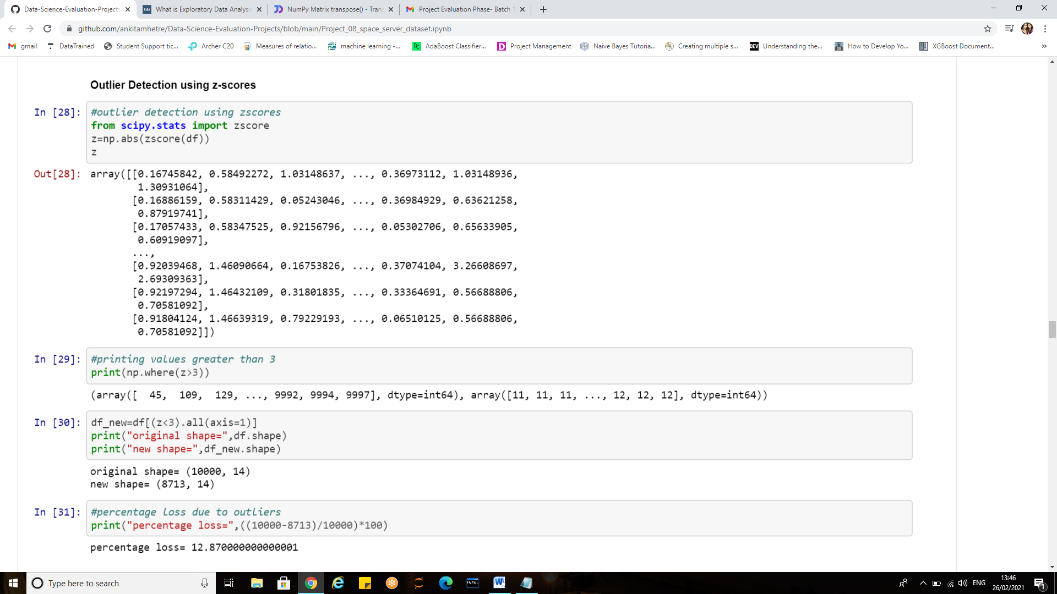

If the z score of a data point is more than 3, it indicates that the data point is quite different from the other data points. Such a data point can be an outlier.

Zscore(df) will give us the z scores the threshold has been set to 3 as the values above 3 are treated as outliers.

The new shape without outliers results in 12% of data loss hence prefer not to drop those records as it may affect the overall performance of model

**EDA Concluding Remarks:**

we have thus made all EDA before making inferences from data in order to examine the essential variables. Statistics and probability is used to figure out trends in data set.

The data distribution, skewness, correlation is checked. Some of the key observations are:

* The u, r, g, z have good relation with target.
* Few features like ‘redshift’, ‘plate’, ’z’ had outliers
* "i" and "z" have normal distributions while rest of the features had either right skew or left skew.
* Among the class, Galaxies are maximum ,quasars are least while Stars are in moderate number
* Camcol 4 is seen for most of the records that is identifying the scanline within the run

*To sum up all, Exploratory Data Analysis is a philosophical and an artistic approach to gauge every nuance from the data at early encounter.*

**Pre-processing pipeline:**

Data pre-processing is an integral step in Machine Learning as the quality of data and the useful information that can be derived from it directly affects the ability of our model to learn;

Therefore, it is extremely important that we pre-process our data before feeding it into our model, which also increases the accuracy and efficiency of a machine learning model.

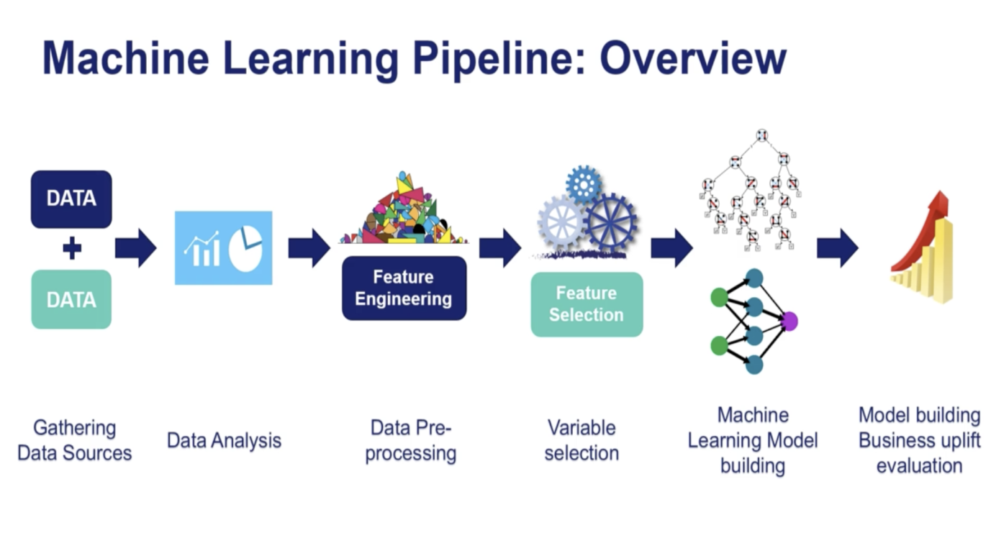

1. **Categorical Encoding**

Machine learning algorithms and deep learning neural networks require that input and output variables are numbers.

This means that categorical data must be encoded to numbers before we can use it to fit and evaluate a model.

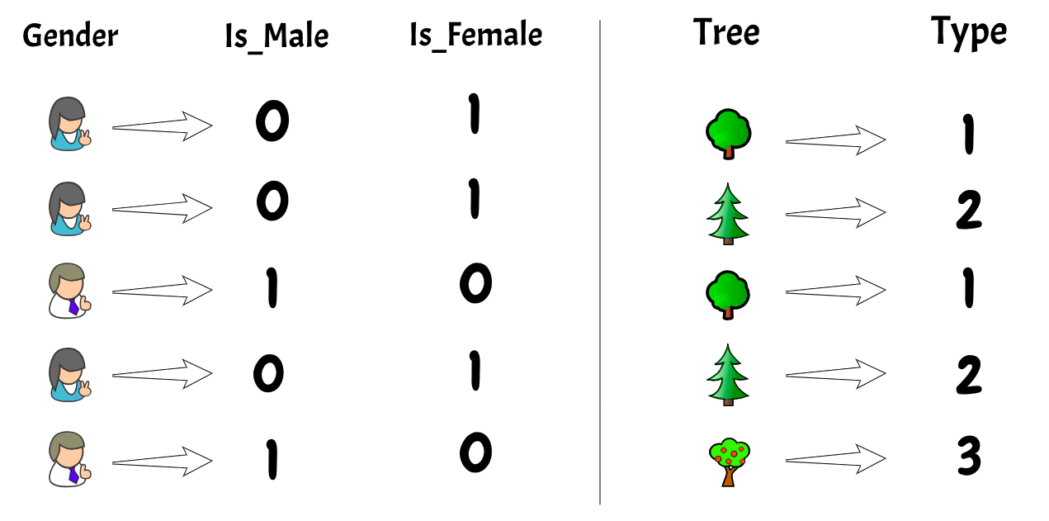

Encoding is a required pre-processing step, when working with categorical data for machine learning algorithms.

Encoders are used to convert categorical data, or text data, into numbers, which our predictive models can better understand.

***Categorical encoding is a process of converting categories to numbers****.*

The two most widely used techniques:

**Label Encoding**: each label is assigned a unique integer based on alphabetical ordering.

### One-Hot Encoding:It simply creates additional features based on the number of unique values in the categorical feature. Every unique value in the category will be added as a feature.

*One-Hot Encoding is the process of creating dummy variables.*

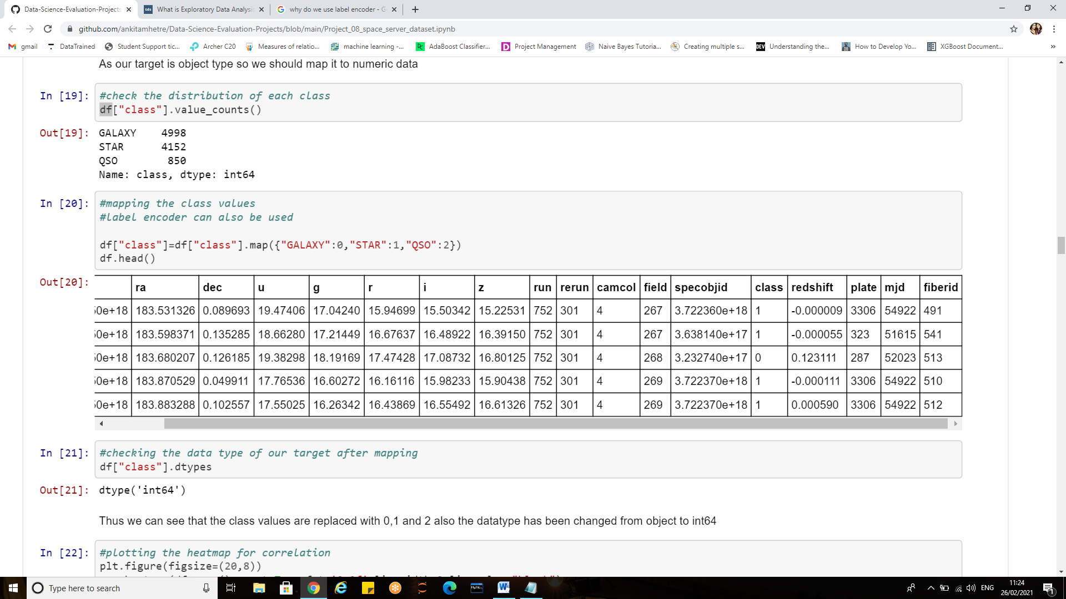

Thus the class values are replaced with 0,1 and 2 also the datatype has been changed from object to int64.

Code for Label encoder :

* From sklearn.preprocessing import LabelEncoder
* Le=LabelEncoder()
* df[‘class’]=Le.fit_transform(df[‘class’])

Code for one hot encoder:

* class=df[‘class’]
* class=pd.get_dummies(class,ignore_first=False)

**2)Handling Variables**:

By now we get a good glimpse of data. It is necessary to remove less correlated variables during feature selection to improve the model.

**Dropping columns that has no relation with target:**

The drop function allows the removal of rows and columns from your DataFrame

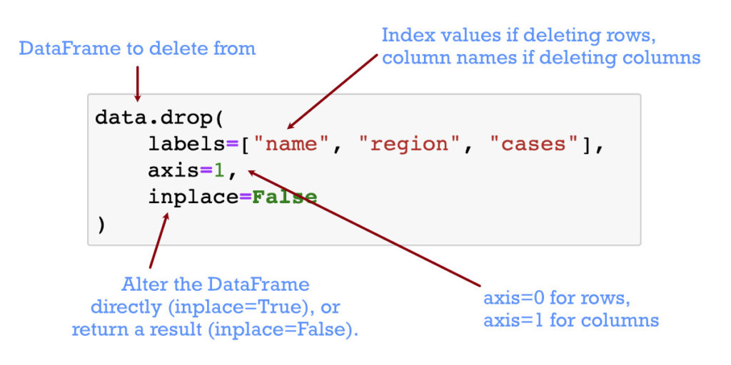

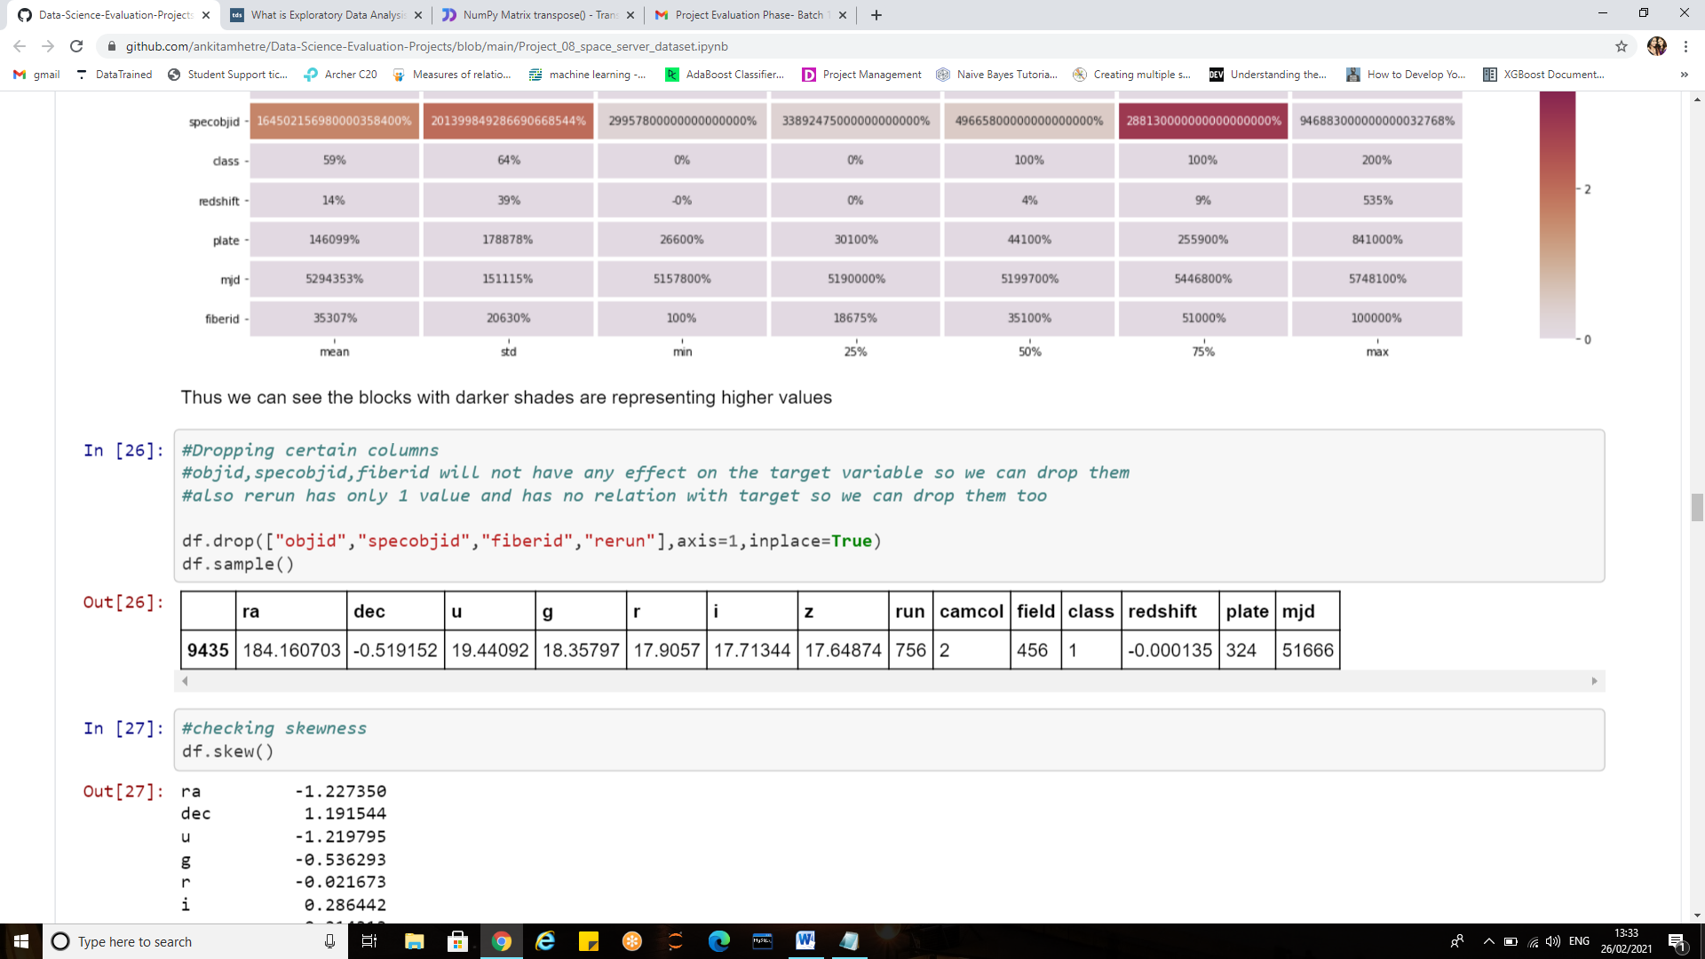

Thus deleting columns and rows is one of the key operations for DataFrames.

1. **Assigning target and features to variables:**

After performing the data cleaning, visualizations and understanding the details of data it is necessary to separate the features(independent variables)from the dependent one(target/label) to train the model

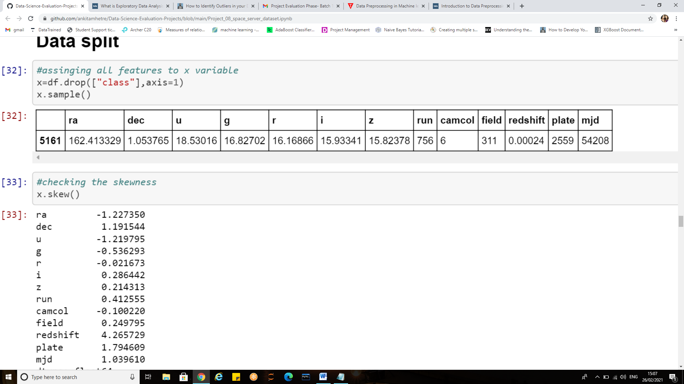

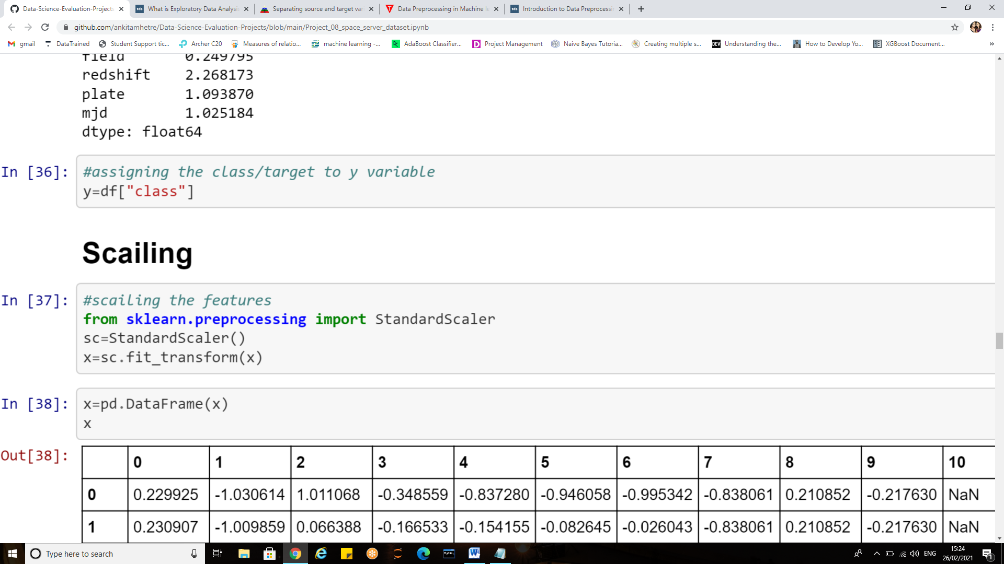

Thus in order to simplify the next steps of data preprocessing, we separated the source variables (independent variables) from the target variable to be predicted (dependent variable) i.e. ‘Class’.

1. **Treating skewness:**

***Why should we treat the skewness of data?***

Many machine learning algorithms prefer or perform better when numerical variables have a Gaussian probability distribution .If the values of a certain independent variable (feature) are skewed, depending on the model, skewness may violate model assumptions (e.g. logistic regression) or may impair the interpretation of feature importance.

Therefore it is often desirable to treat the skewness  So, the more the data is close to normal, the better it is for getting good predictions.

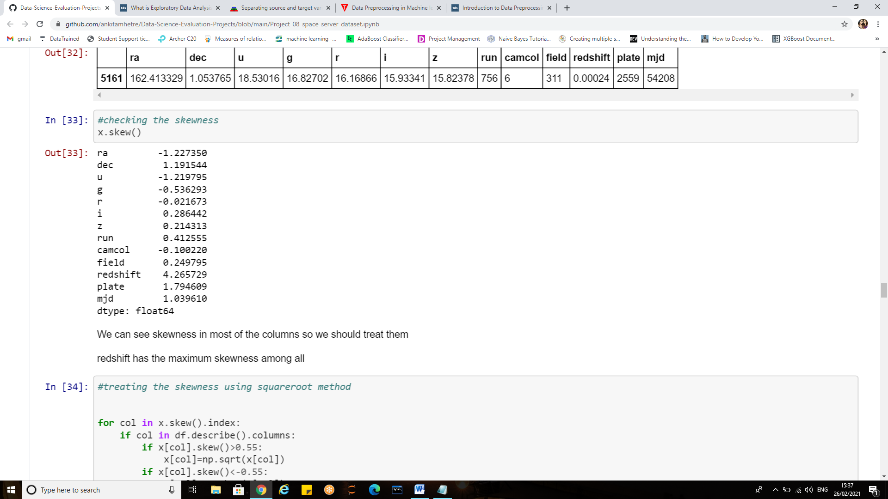

We can see skewness in most of the columns so we should treat them.’redshift’ has the maximum skewness among all.

We can address skewed variables by transforming them (i.e. applying the same function to each value). Common transformations include **square root (sqrt(x)), logarithmic (log(x)), Box Cox Transformation and reciprocal (1/x).**

**To handle the right skewness, we use:**

* logarithms (best for it)
* [square root and cube root](https://www.kaggle.com/questions-and-answers/good)
* reciprocals (weak)

**To handle left skewness, we use:**

* squares
* cubes
* Higher powers.

Here, sqrt method is used to treat the skewness. 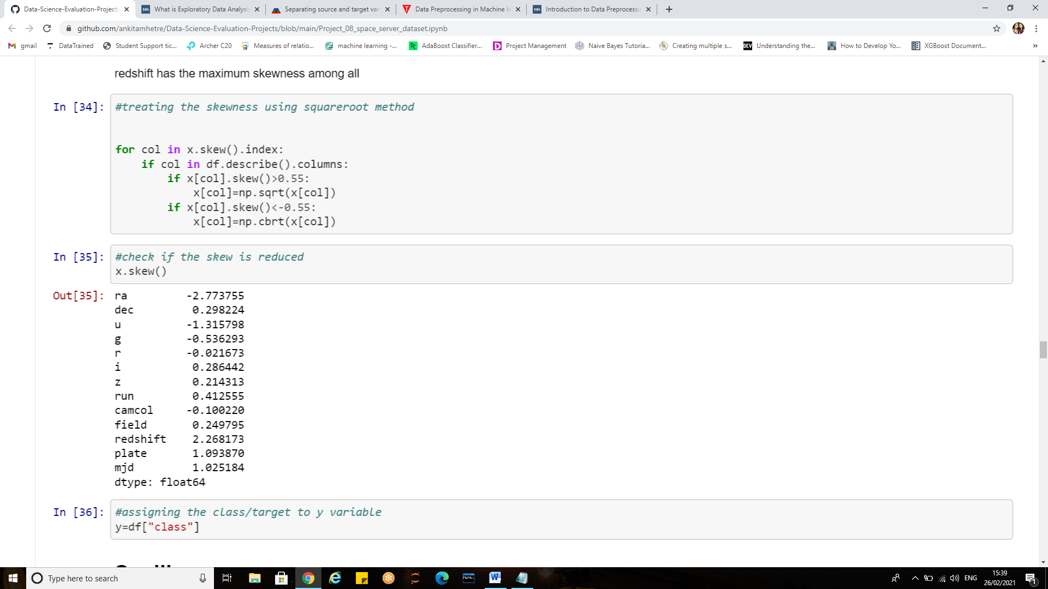

**Power transforms** are a technique for transforming numerical input or output variables to have a Gaussian or more-Gaussian-like probability distribution. Scikit-learn library provides Power transforms like the **Box-Cox** transform and the **Yeo-Johnson** transform which provides an automatic way of performing these transforms on data

**Note:**

* The target variable should not be treated for skewness.
* Box-cox method can be used to treat only positive skew

1. **Standardization**

It is another integral pre-processing step. In Standardization, we transform our values such that the mean of the values is 0 and the standard deviation is 1.

If the features in dataset are not on the same scale our model will give different weightage to each feature, which is not the ideal scenario. In order to avoid this issue, we perform Standardization.

**MinMaxScaler(feature range = (0, 1))** will transform each value in the column proportionally within the range [0,1]. Use this as the first scaler choice to transform a feature, as it will preserve the shape of the dataset (no distortion).

**StandardScaler()** will transform each value in the column to range about the mean 0 and standard deviation 1, i.e., each value will be normalised by subtracting the mean and dividing by standard deviation. Use StandardScaler if you know the data distribution is normal.

If there are outliers, **use RobustScaler().** Alternatively you could remove the outliers and use either of the above 2 scalers (choice depends on whether data is normally distributed)

We don’t need to do this process manually as sklearn provides a function called **StandardScaler and MinMaxScaler.**

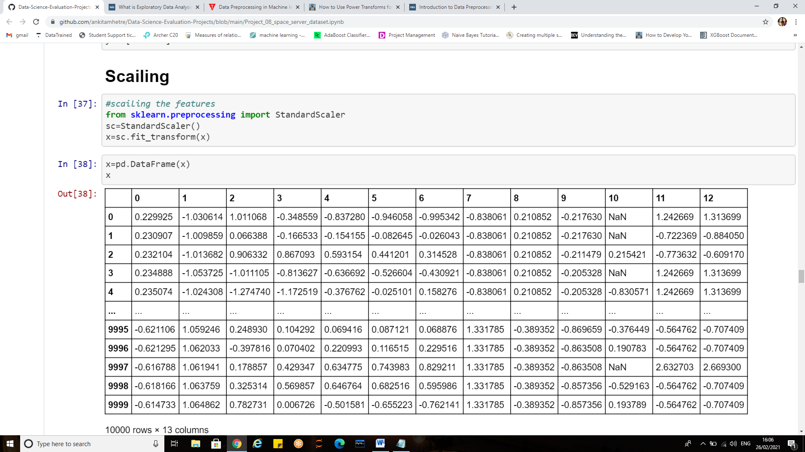

**fit_transform** is equivalent to using fit and then transform.

**Note:** use only the transform method when dealing with the test data*.*

1. **Handling the null values due to transforms.**

Pandas treat None and NaN as essentially interchangeable for indicating missing or null values. In order to check missing values in Pandas DataFrame, we use a function isnull() and notnull().

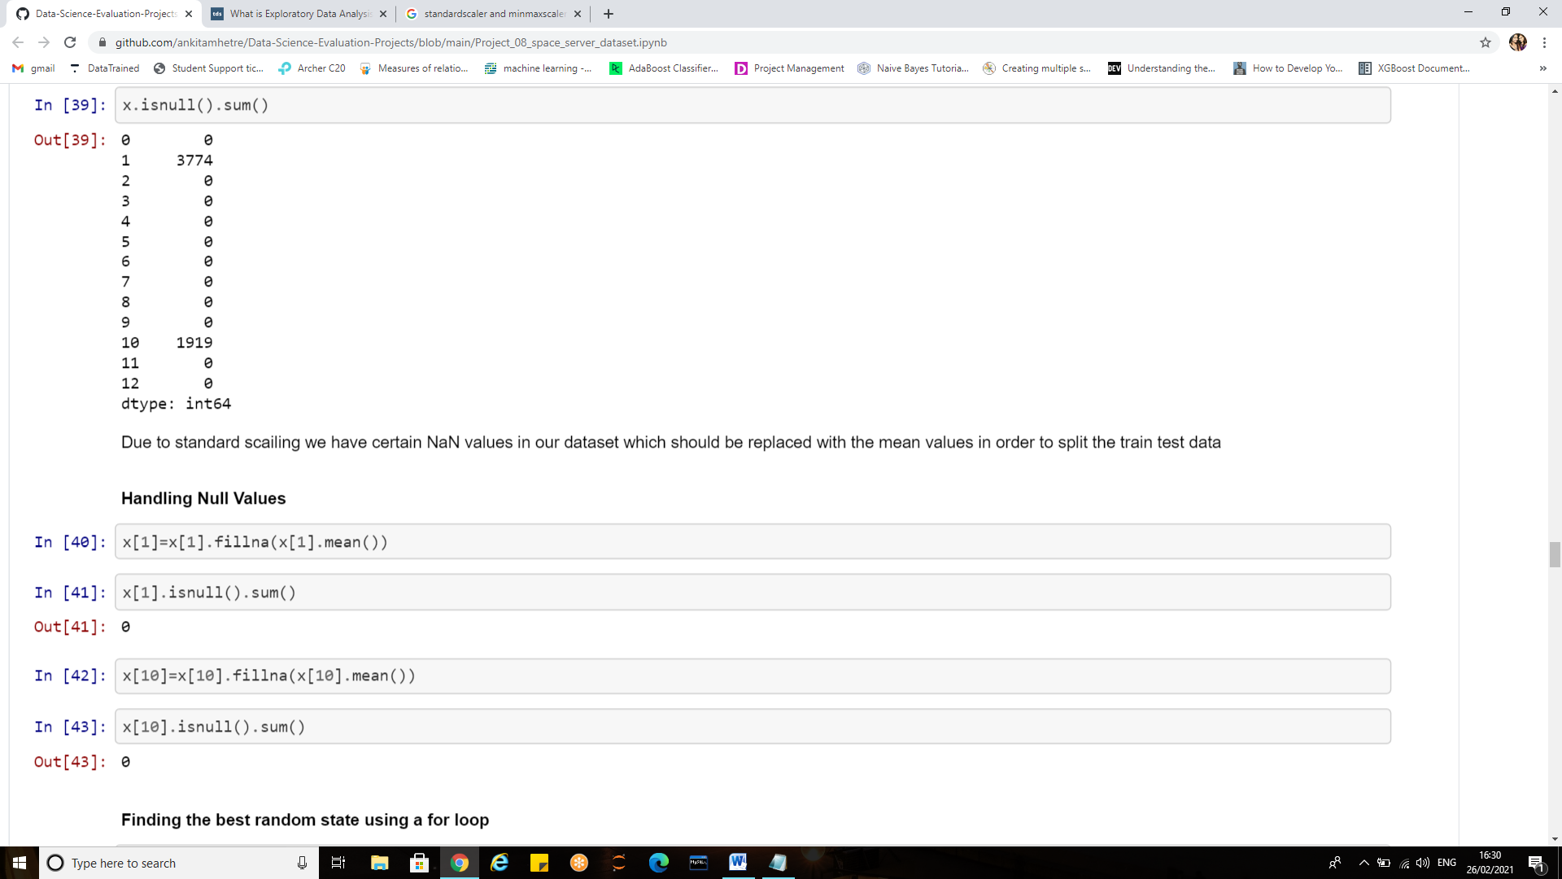

The null values are filled with the mean values using fillna ().mean()

1. **Splitting the Dataset into the Training set and Test set**

The procedure involves taking a dataset and dividing it into two subsets. The first subset is used to fit the model and is referred to as the training dataset.

The second subset is not used to train the model; instead, the input element of the dataset is provided to the model, then predictions are made and compared to the expected values. This second dataset is referred to as the test dataset.

* Train Dataset: Used to fit the machine learning model.
* Test Dataset: Used to evaluate the fit machine learning model.

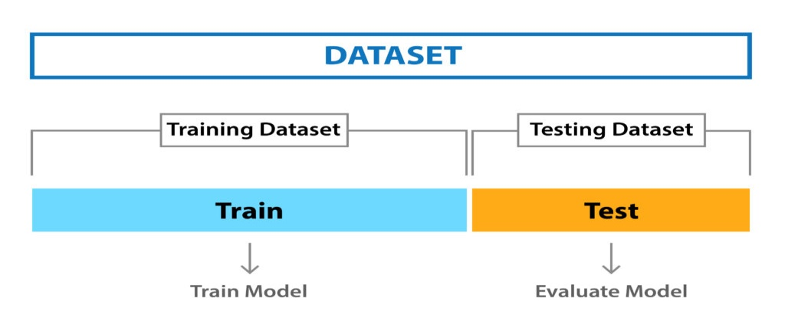

**Note:** Before we split the data into train and test sets we should find the best random state using loop

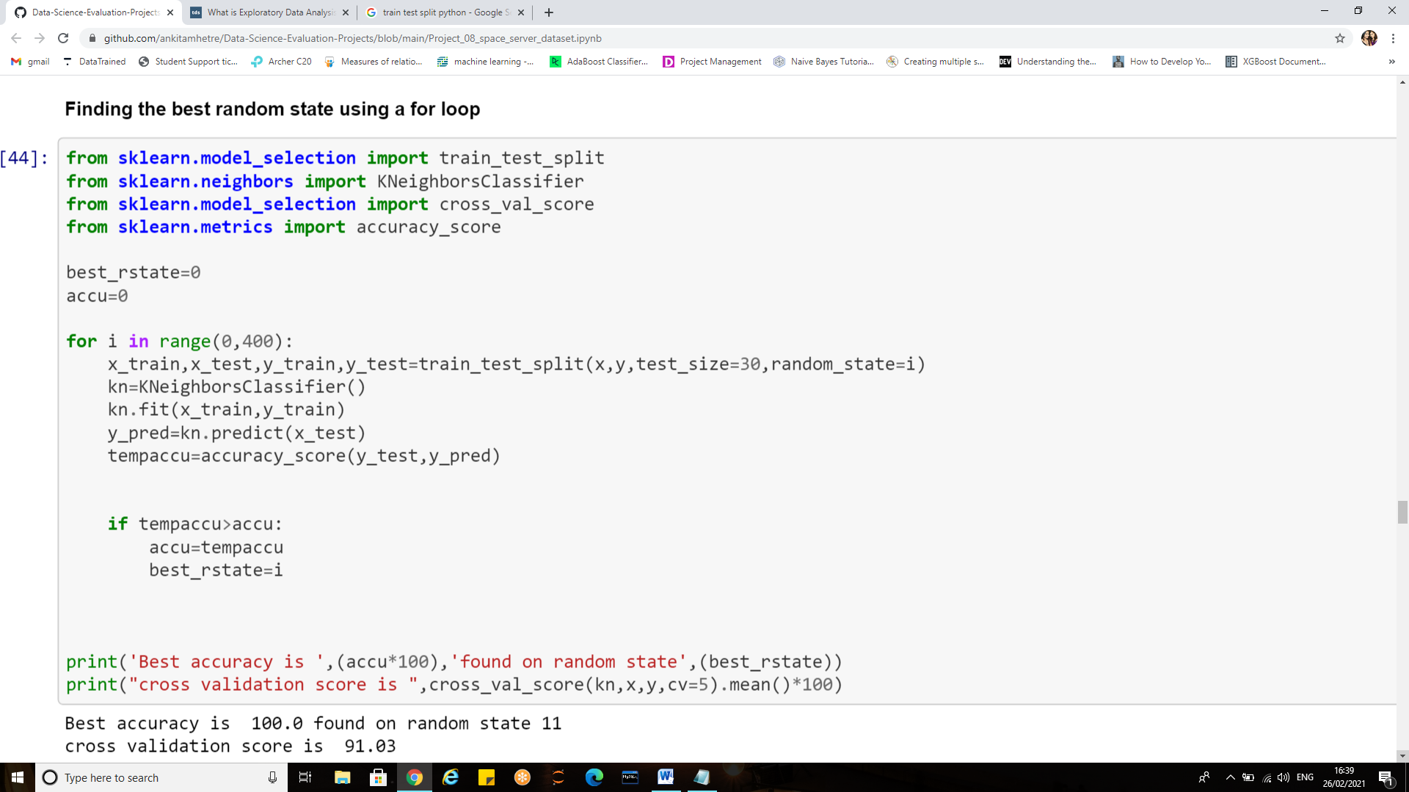

Thus random state 11 is giving the best accuracy

1. **Data split**

Based upon the best random state found we proceed with the splitting of dataset into train and test set

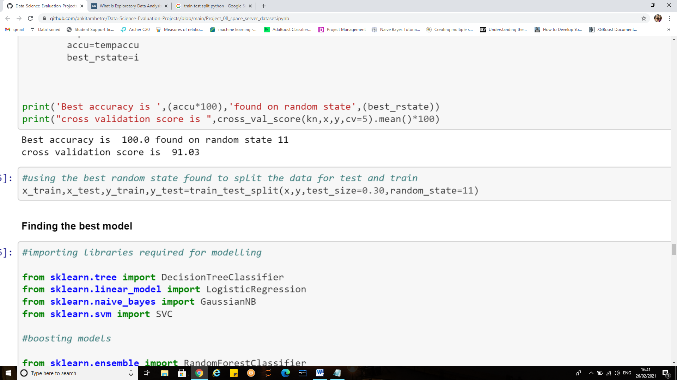

Train size=70% of the dataset

Test Size=30% of the dataset

**Building Machine Learning Model:**

A machine learning model is a file that has been trained to recognize certain types of patterns. You train a model over a set of data, providing it an algorithm that it can use to reason over and learn from those data.



**Importing all required libraries:**

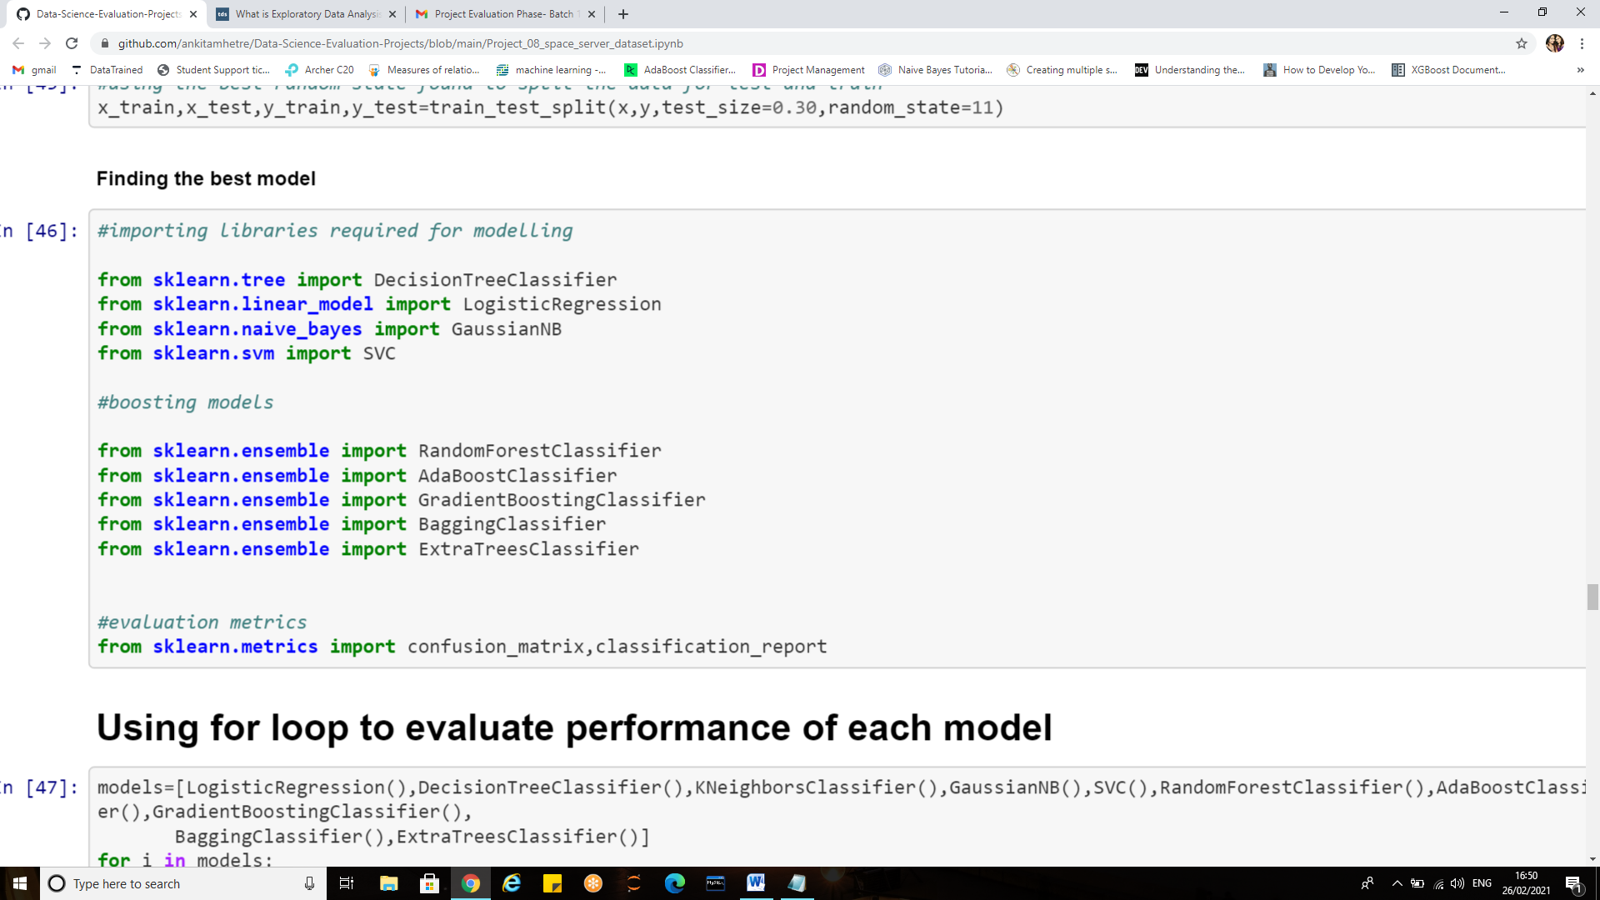

Before building our model using any one algorithm let us study the performance of various algorithms and then decide for the best one,For which here we use a loop and understand the general outcomes.

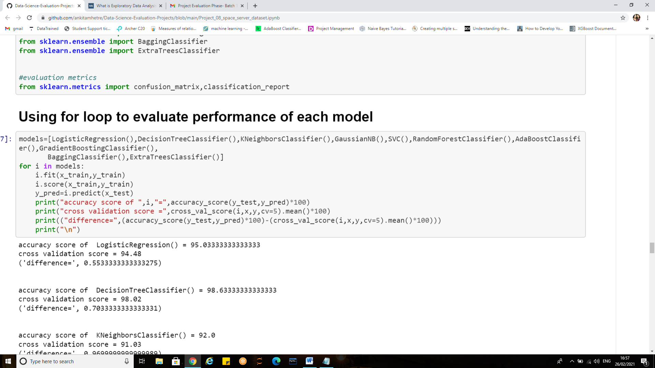

To select the best of all consider the one which yields us the minimum difference between its accuracy and the cross validation score.

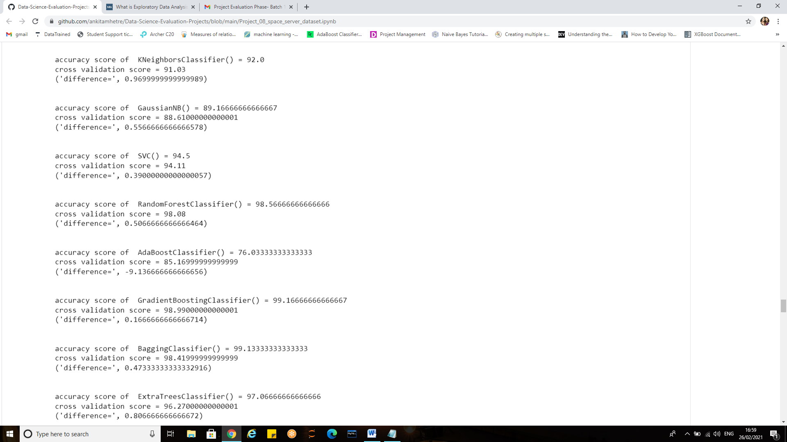

#### Thus the differences between cross validation and accuracy score is less for SVC, Gradient Boosting, DecisionTree and randomForest. we shall hyper tune them and see for the best model after hypertuning.

**Hyper Tuning the models:**

When creating a machine learning model, we'll be presented with design choices as to how to define our model architecture. Often times, we don't immediately know what the optimal model architecture should be for a given model, and thus we'd like to be able to explore a range of possibilities.

In machine learning we'll ideally ask the machine to perform this exploration and select the optimal model architecture automatically.

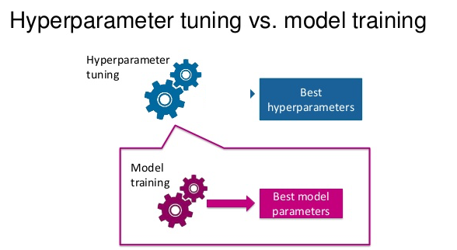

Parameters which define the model architecture are referred to as **hyper parameters** and thus this process of searching for the ideal model architecture is referred to as **hyper parameter tuning.**

Models can have many hyperparameters and finding the best combination of parameters can be treated as a search problem.

Two best strategies for Hyper-parameter tuning are:

* [GridSearchCV](https://scikit-learn.org/stable/modules/generated/sklearn.model_selection.GridSearchCV.html)
* [RandomizedSearchCV](https://scikit-learn.org/stable/modules/generated/sklearn.model_selection.RandomizedSearchCV.html)

**SVC**

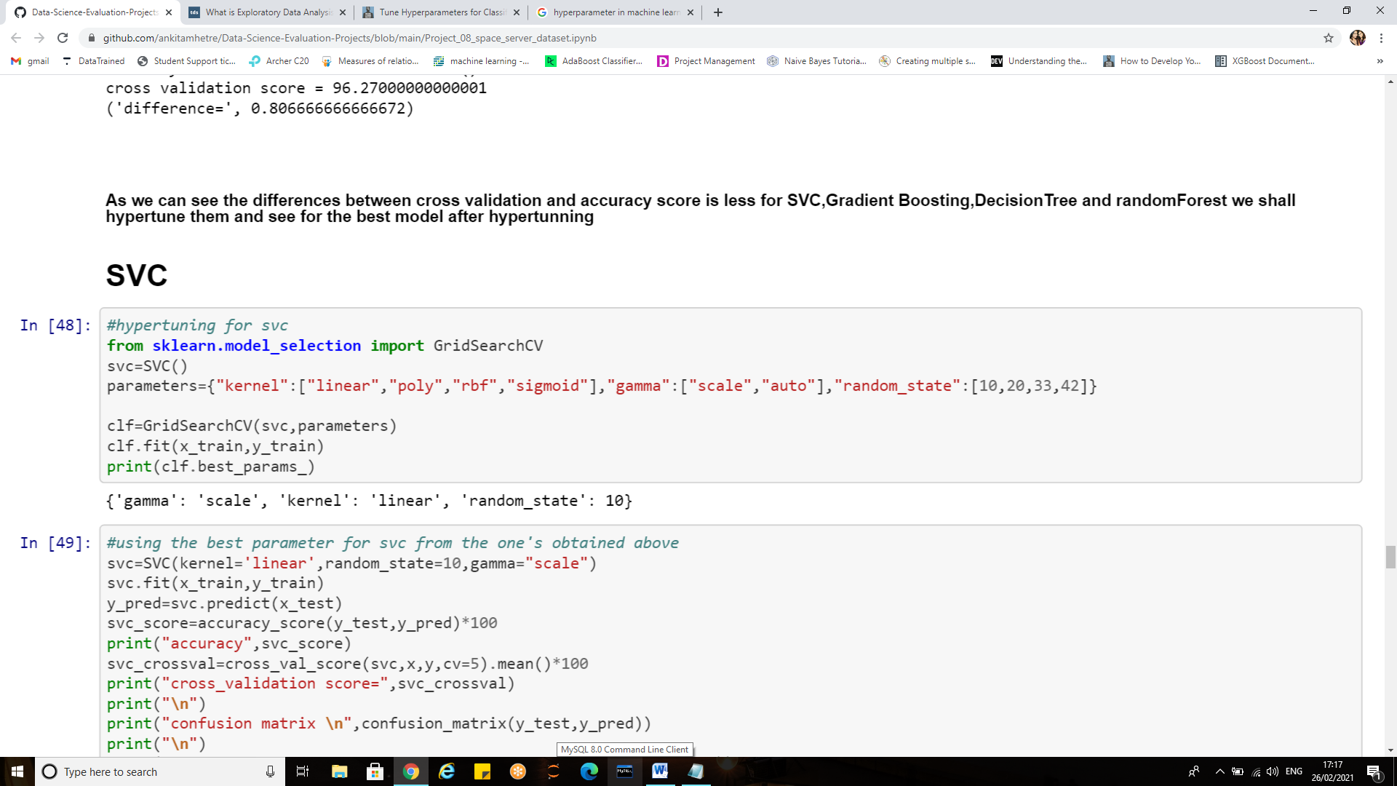

**Evaluation metrics for svc**

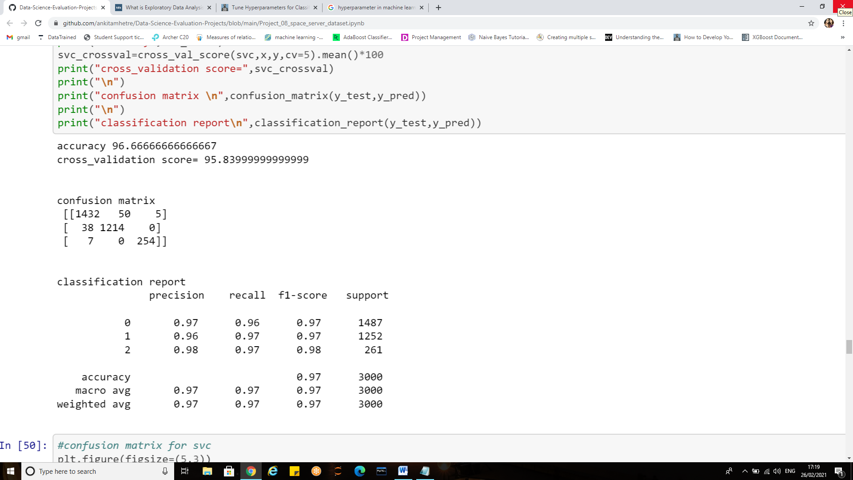

**Confusion Matrix for SVC**

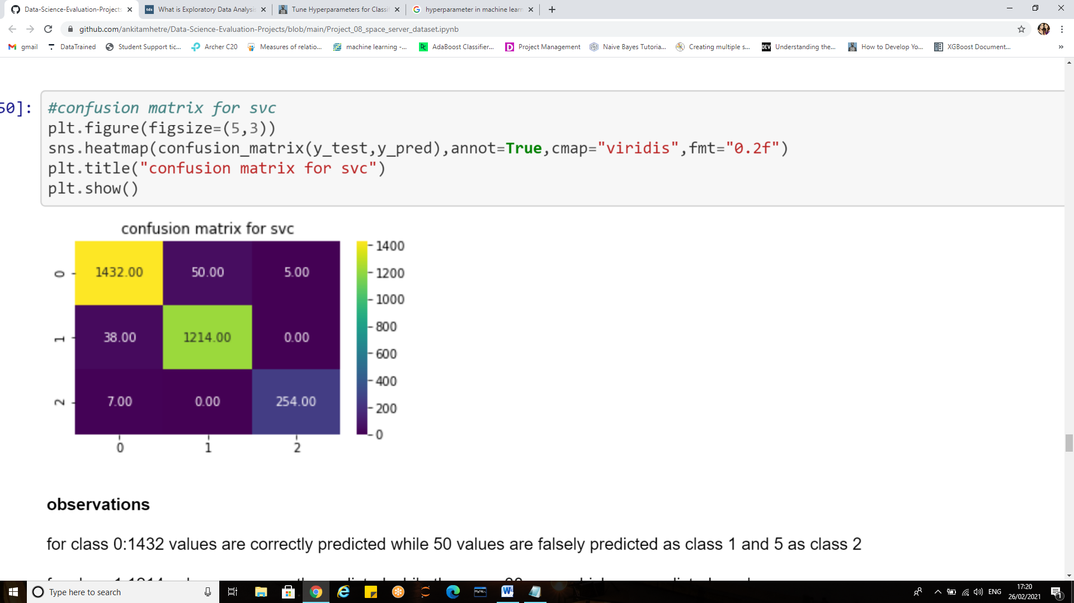

**Reading the confusion matrix for svc:**

**For class 0**:1432 values are correctly predicted while 50 values are falsely predicted as class 1 and 5 as class 2

**For class 1**:1214 values are correctly predicted while there are 38 error which are predicted as class 1

**For class 2** : 254 values are correctly predicted while 7 are wrongly predicted as class 0

**Note:** similarly after hyper-tuning all the models the results obtained were as follows**:**

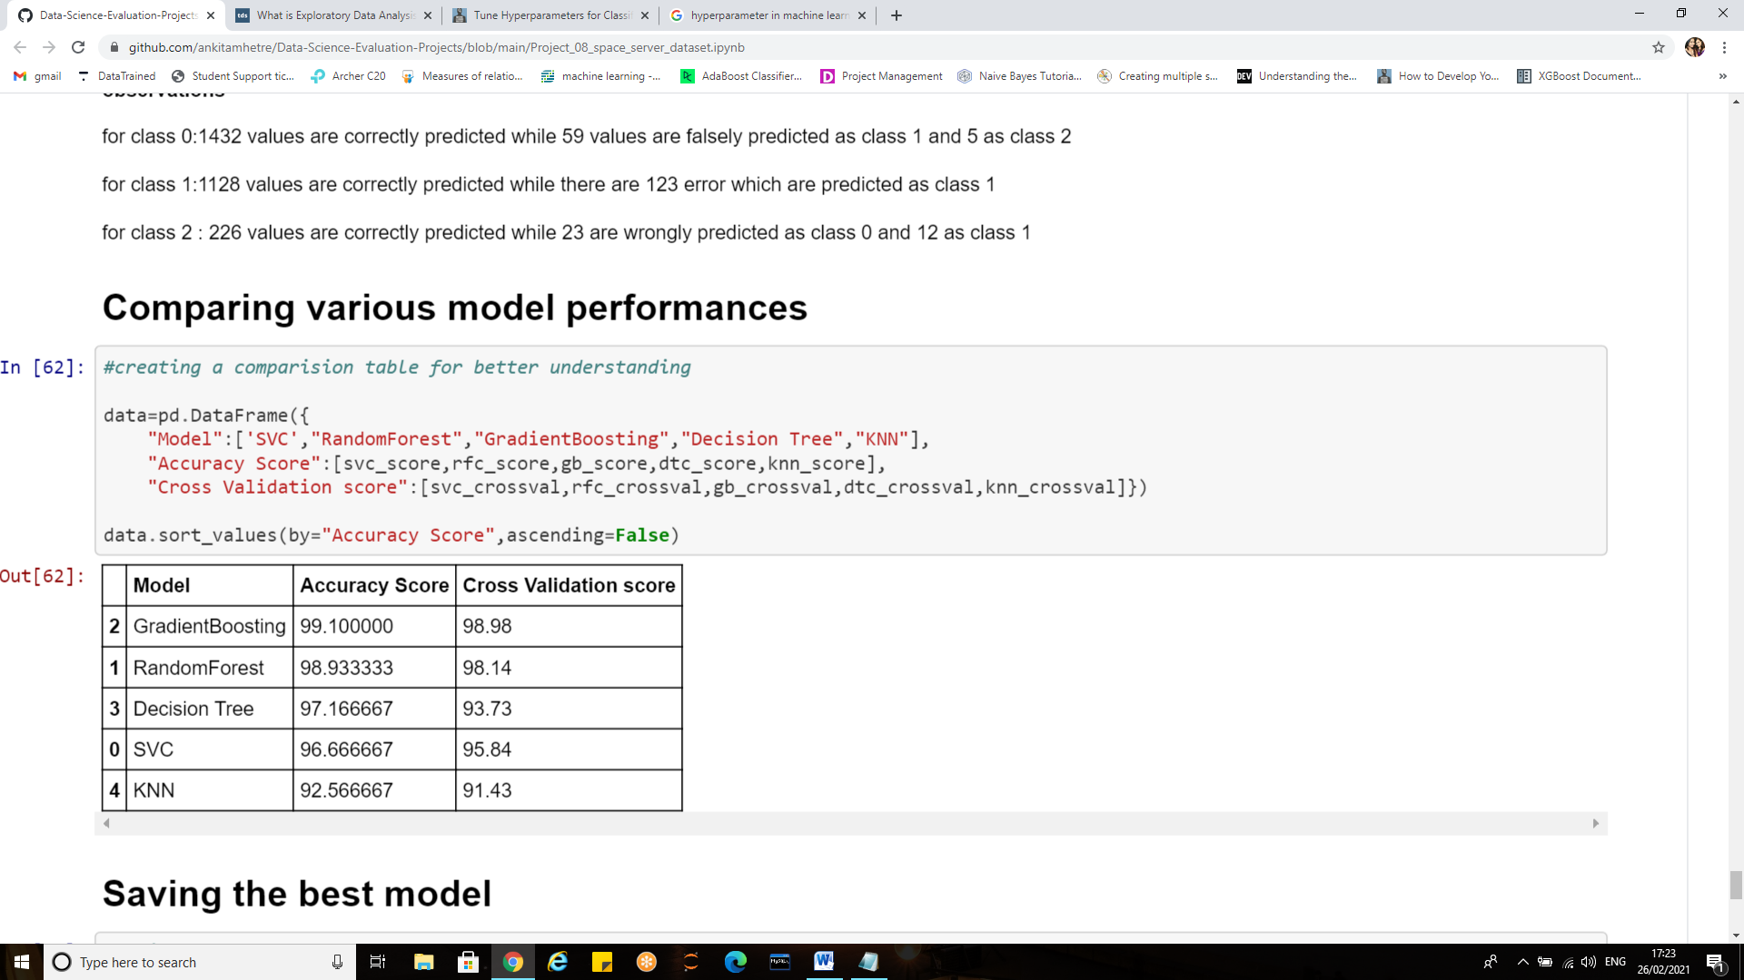

Random Forest gives good accuracy as well as cross validation score therefore we shall build our model using randomForest algorithm.

**Hyper parameter tuning for random forest:**

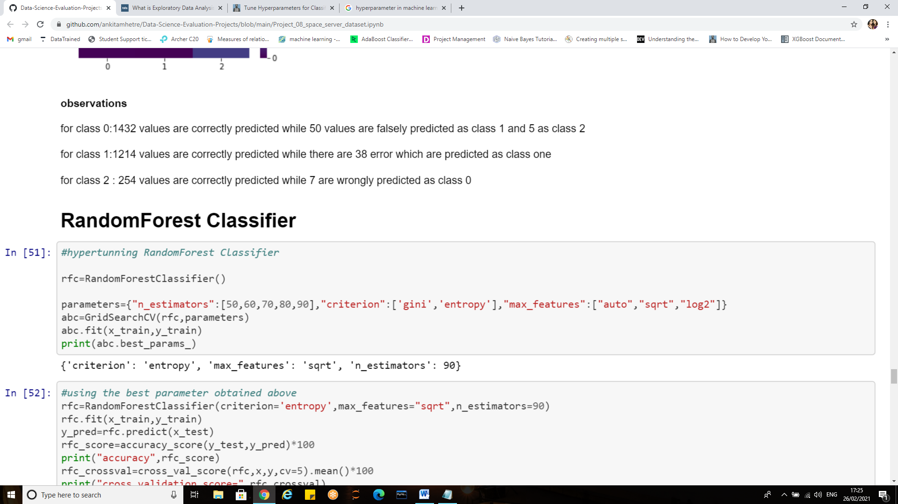

The hyper parameters which I decided to focus on are:

**n_estimators**: (number of trees in the forest)

**max_features** (max. no. of features used in node splitting, usu. < no. of features in dataset)

**Criterion** (metric used to determine stopping criteria for the trees)

**Using the best parameters obtained to build the model**

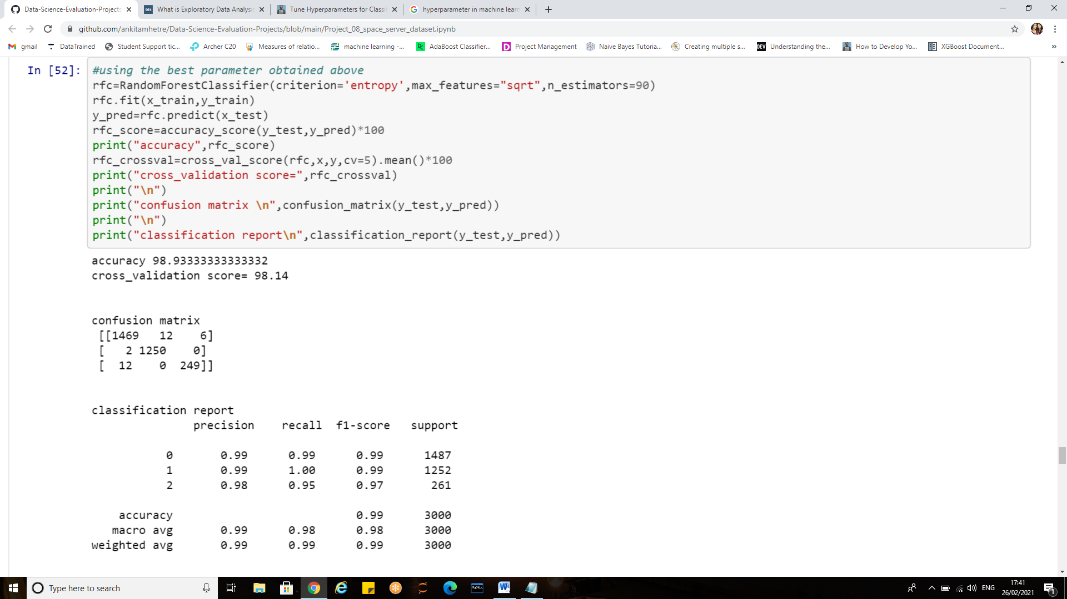

**Cross Validation Score:**

Cross-validation is primarily used in applied machine learning to estimate the skill of a machine learning model on unseen data, in order to flag problems like over-fitting or selection bias and to give an insight on how the model will generalize to an independent dataset (i.e., an unknown dataset, for instance from a real problem).

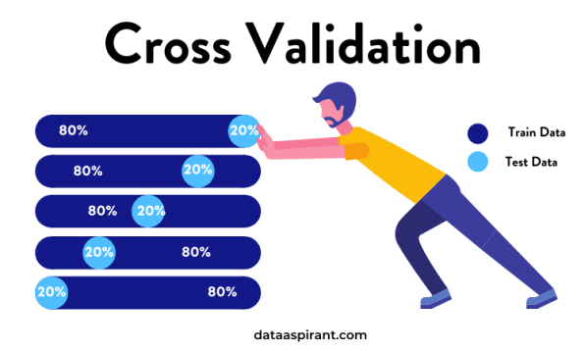

This approach involves randomly dividing the set of observations into k groups, or folds, of approximately equal size. The first fold is treated as a validation set, and the method is fit on the remaining k − 1 folds*.*

So **cross_val_score** estimates the expected accuracy of model on out-of-training data (pulled from the same underlying process as the training data, of course).

**Accuracy Score**

Classification accuracy (Accuracy score) is the number of correct predictions made as a ratio of all predictions made.

### Classification Report

Scikit-learn do provide a convenience report when working on classification problems to give a quick idea of the accuracy of a model using a number of measures.

The classification_report () function displays the precision, recall, f1-score and support for each class.

The scikit-learn documentation explains these concepts best

**Confusion matrix for random forest**

The confusion matrix is a handy presentation of the accuracy of a model with two or more classes.

The table presents predictions on the x-axis and accuracy outcomes on the y-axis. The cells of the table are the number of predictions made by a machine learning algorithm.

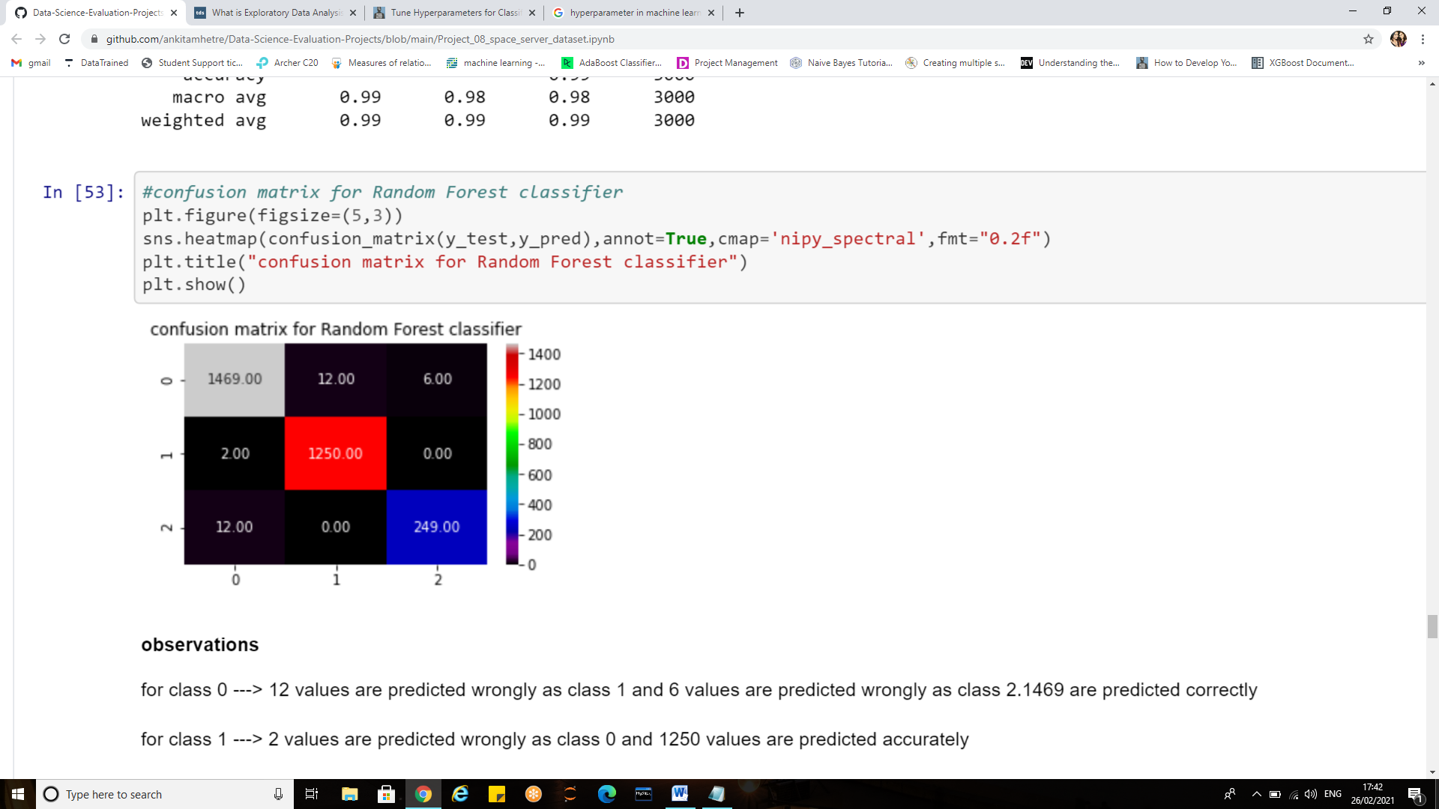

**Reading the confusion matrix**:

**for class 0** ---> 12 values are predicted wrongly as class 1 and 6 values are predicted wrongly as class 2.1469 values are predicted correctly

**for class 1** ---> 2 values are predicted wrongly as class 0 and 1250 values are predicted accurately.

**for class 2**---> 12 values are predicted wrongly as class 0 and 249 values are predicted accurately.

**Saving the best model:**

After trying and testing various classification algorithms the final step is to save the best trained model so that we can restore them and use the fitted/trained model in future to make predictions on new data.



The saving of data is called **Serialization**, while restoring the data is called **Deserialization.**

* **pickle.dump** to serialize an object hierarchy, you simply use dump ().
* **pickle.load** to deserialize a data stream, you call the load() function*.*

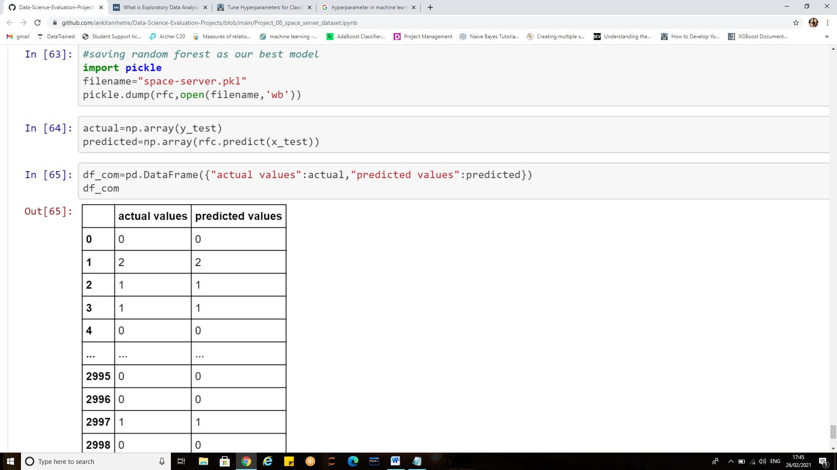

The model can also be saved using **joblib**

Joblib is the replacement of pickle as it is more efficient on objects that carry large numpy arrays.

* joblib.dump to serialize an object hierarchy
* joblib.load to deserialize a data stream

The predicted values can also be stored **as csv file** using the following syntax:

pd.to_csv (“filename.csv”)

The csv file will be reflected on the home page.

**Conclusion**

* Thus the Sloan digital sky server dataset was a multi-label classification problem with the target variable ‘class’ having more than 2 categorical values which were star, galaxies and quasars.
* We have performed various data cleaning and pre-processing techniques before proceeding with the model building.
* After evaluation of various algorithms it was found that "Random Forest classifier" gave the best possible accuracy which lead to correct predictions.
* The model has accuracy score of 98.93 and cross validation equals to 98.14.
* Various evaluation metrics such as accuracy score, cross validation, classification report and confusion matrix are also observed.

**References**

[**https://www.sdss.org/dr16/**](https://www.sdss.org/dr16/)

[**https://classic.sdss.org/**](https://classic.sdss.org/)

<https://www.learndatasci.com/tutorials/python-pandas-tutorial-complete-introduction-for-beginners/>

[**https://www.kaggle.com/zeydustaoglu/data-analysis-and-classification-using-xgboost**](https://www.kaggle.com/zeydustaoglu/data-analysis-and-classification-using-xgboost)

[**https://towardsdatascience.com/exploratory-data-analysis-8fc1cb20fd15#:~:text=Exploratory%20Data%20Analysis%20refers%20to,summary%20statistics%20and%20graphical%20representations**](https://towardsdatascience.com/exploratory-data-analysis-8fc1cb20fd15#:~:text=Exploratory%20Data%20Analysis%20refers%20to,summary%20statistics%20and%20graphical%20representations)**.**

[**https://www.itl.nist.gov/div898/handbook/eda/section1/eda11.htm**](https://www.itl.nist.gov/div898/handbook/eda/section1/eda11.htm)

**Thank you.**